Chapter 2
A Tutorial on Microsoft Excel
2.1 Introduction
In this chapter we aim to briefly cover the basics of Excel and explain how to do elementary computations. For experienced readers, most part of this chapter will be familiar. We are covering only those aspects of Excel that are needed to be able to follow the later chapters in this book. For those who have no experience with Excel, spending time with one of the many guides to Excel that are available is suggested. Note that Excel comes in many versions. This book is based on Excel 2007 and for some of the material covered here, earlier and later versions of Excel may do things differently.
The Microsoft Excel is a spreadsheet package and looks like the traditional paper columnar pad or spreadsheet. Information can be entered into the spreadsheet and calculated by the program. The files that Excel uses are known as workbooks. An Excel workbook can contain one or more worksheets. A worksheet resembles a sheet of columnar ledger paper. The worksheet is divided into vertical columns and horizontal rows. The meeting of a column and row is called a cell. Any cell can be made active cell by either clicking on that cell or navigating using the arrow keys. All the cells have its own address, which is compose of the column heading attached to the row number. The column headings are alphabets and the rows are numbered. There are 256 columns (A, B…. Z, AA, AB,…IU, IV…XFC, XFD) and there are 1048576 rows(1,2…..1048576) in Microsoft Excel 2007. The active cell address is displayed in the formula bar.
Various inbuilt functions are available for the users to ease their work. The set of functions available are comprehensive and satisfy the various needs. The users can also create their own custom functions. The functions are available on statistics, finance, mathematics, date, time and various others. There are formulas available for counting and summing, which are handy when the operation becomes larger. Pivot table, one of the best data analysis tools provided by Excel helps in dynamically summarizing information contained in the database or list [2].
The output of the various calculations can be analyzed using the charts that are available. This makes the analysis, the purpose of any spreadsheet, to be complete and useful. Excel even allows importing data from the external databases and is compatible with various data types.

2.2 Addressing Schemes
a. Relative Cell Addressing: The contents of some of the cells may not be what you expect although they may be what we want. When the formula or relative addressing in a cell is copied or moved, they are altered as they move. This is because the address of the cell is stored as a relative distance of location from one cell. However when the address or formula is copied or moved, the relative location becomes different with respect to that cell.
For Example:
Enter a value in any cell, say: D10 as 11(Fig 2.2.1)
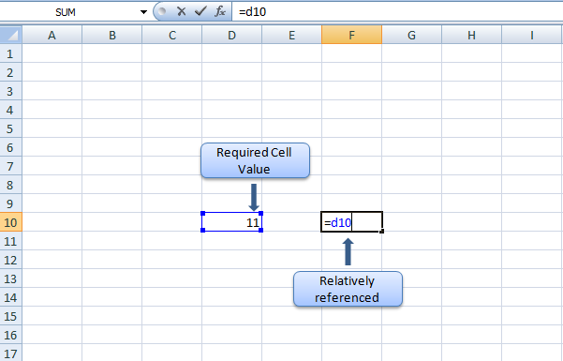
Fig 2.2.1: Relative addressing (case 1)
Enter the reference of D10 in F10 by simply entering =D10. And we get the value 11 in C10 also. Suppose we were to drag the cell F10 to another point by selecting the cell and drag down one cell, the formula is transferred to the corresponding covered cell. However the value is not copied as the relative distance between the target cell and the addressing cell has changed and the value in cell F11 would be the value in D11.This would be of help when we have a dynamic function to do (Fig 2.2.2)
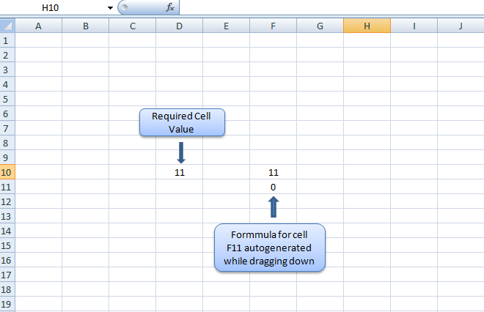
Fig 2.2.2: Relative addressing (case 2)
e.g. would be if we want the corresponding sums of 2 columns in a 3rd column.
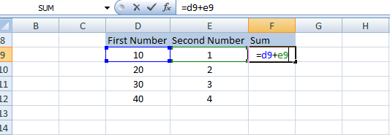
Fig 2.2.3: Relative addressing (case 3)
We have a set of values in column D9 to D12, another set in E9 to E12 and the required sum to be placed in the rows from F9 to F12.All we need to do is place the formula A9+B9 in the cell F9 and drag it down to F12 (Fig 2.2.3).
b. Absolute Cell Addressing:
An alternative to Relative Addressing would be to use absolute addressing, whereby the addresses would not change as it is moved or copied. Here we use the symbol ‘$’ before the component of the cell reference which we don’t want to change. It could either be a row or column component.
Reference Style Meaning
$A$1 | Both the column and row reference are fixed. Neither will be incremented nor changed during a copy nor fill operation.
$A1 | Only the column reference is fixed. It will not change during a fill or copy, but the row will change.
A$1 | Here the row reference is fixed. It will not change during a fill or copy, but the column will change.
For e.g.:
Suppose we need to multiply a column of elements from A9 to A12 by a value in B9 and get the result in C9 to C12.In that case all we need to do is to insert the formula as A9*B$9 and drag it to C12 to get the answer. Here, the $ symbol before the row number 9 makes it unchangeable (i.e. the row value will not increase as we pull down the formula). Since we are not dragging across the column, there is no need for a $ sign before the letter B representing the column.
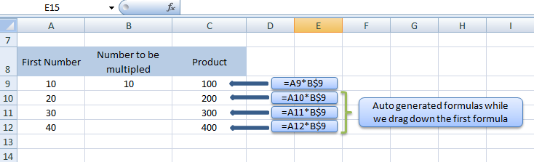
Fig 2.2.4: Absolute Referencing

We will see an example below where both rows and columns changes. We have a set of values from A9 to A12 and another set of values from B8 to E8. Now, we want to find the product of A9 and B8 in B9, A9 and C8 in C9,......... A10 and B8 in B10 and so on (Fig 2.2.4)
For this, we can write the formula $A9 * B$8 in the cell B9 and drag it across first and drag the whole row down till E12 (Fig 2.2.5)
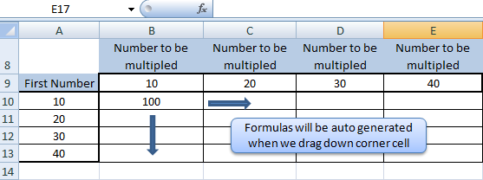

Fig 2.2.5: Absolute Referencing

2.3 Essential Excel Functions
- IF Condition
This function returns one value if a condition you specify evaluates to TRUE and another value if it evaluates to FALSE. The IF condition is a most often used formula/function in excel implementations. The below example will explain the use of IF condition.
- Normal IF Condition
Consider in a class there are 60 students. Figure 2.3.6 shows the marks obtained by 5 students for a particular subject. The teacher needs to make the pass/fail list for all students. For this all the teacher needs to do get all the student data on to an excel sheet, where the first column “A” shows the student name and the second column ”B” shows their corresponding marks. To get the pass or fail status type 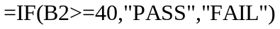in column “C1”. This will give the result for the first student – Sam. Now just bring the cursor to the bottom right corner of the cell “C1” and then drag it down for all the 60 students. The FAIL/ PASS status will be updated on the column “C”. Thus the job of teacher is made easy.

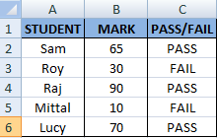
Figure 2.3.6: Normal IF example
- Nested IF Condition
The nested IF condition is nothing but, an IF condition which come within an IF condition. This comes helpful when multiple conditions need to be checked simultaneously. Now in the above said example if we need to specify the class for each student i.e. second Class, first class, and distinction. This can be done by typing the following formula in cell D1- =IF(B2<40,"FAIL",IF(AND(B2>=40,B2<60),"SECOND CLASS",IF(AND(B2>=60, B2<75),"FIRST CLASS","DISTINCTION"))). Now drag it down for all the 60 students. This implementation is shown in figure 2.3.7.
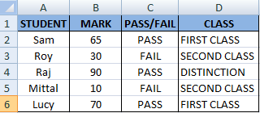
Figure 2.3.7: Normal IF example
- INDEX
Index is another inbuilt function in excel which is used for referencing and lookup. The INDEX works similar to VLOOKUP. The difference of INDEX from VLOOKUP is in the fact that there is no searching or search tag being specified and the row as well as column value has to be explicitly specified by the user. The INDEX function takes in three parameters or arguments namely the range of cells of the array being indexed, the row number and the column number.
The syntax of INDEX function is given as follows:
INDEX (array, row_num, column_num)
For understanding the indexing process let us consider the following example. We create a matrix of fruits having the names of different fruits. In the example, we have considered a 3 by 3 matrix. The problem to be solved is to find the name of the fruit given its row number and column number. As the solution to the problem, we utilize the index function and implement a formula given by INDEX ($B$7:$D$9,$I$8,$M$8) where the cell range from $B$7 to $D$9 represent the “Matrix of fruits”, the cell range $I$8 represents the row number which is given by the user and the cell range $M$8 represents the cell range representing the column number given by the user. The following screenshot illustrates the explanation above.

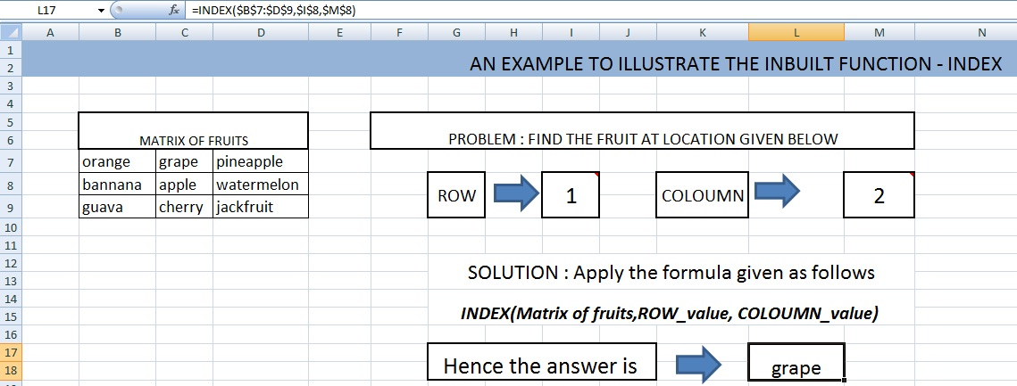
Figure 2.3.8: Index example
From the above example, we understand that the INDEX function returns the value of the table matrix at the intersection of the row and column value. But then again, if the INDEX function is called by setting the parameters of row number and column number as zero, then the INDEX function is said to return the complete value of the array or reference table which is given as its parameter. But when we type the INDEX formula in a single cell with row number and column number as zero’s we obtain a VALUE error. In order to obtain the values of the complete array when we specify the value of row and column to be zero, we have to select a range of cell equivalent to the size of the input array and type the formula INDEX(B9:D11,0,0) where B9:D11 is the input matrix cells range, and press ‘Control + Shift + Enter’. The following screenshots provides the illustration:
STEP 1: Select a equivalent range as compared to the input array (Matrix of fruits)
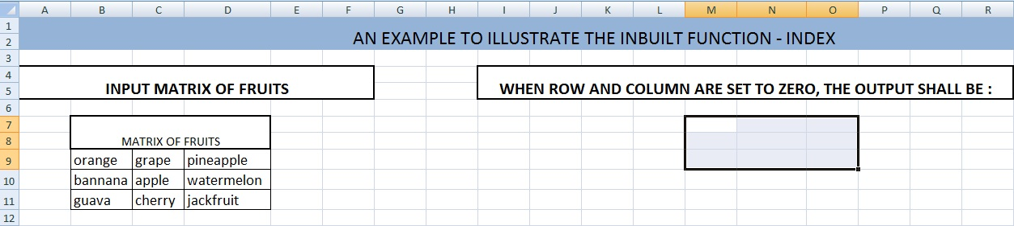
Figure 2.3.9: Index (step 1)
STEP 2: Enter the INDEX formula with row and column set to zero and input array set as Matrix of fruits in the first cell of the selected matrix.
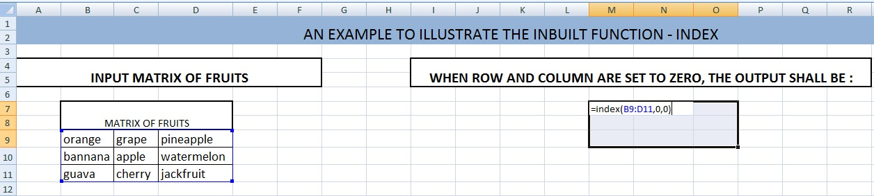
Figure 2.3.10: Index example (step 2)

STEP 3: Press Ctrl + Shift + Enter, one key after the other to obtain the final result.
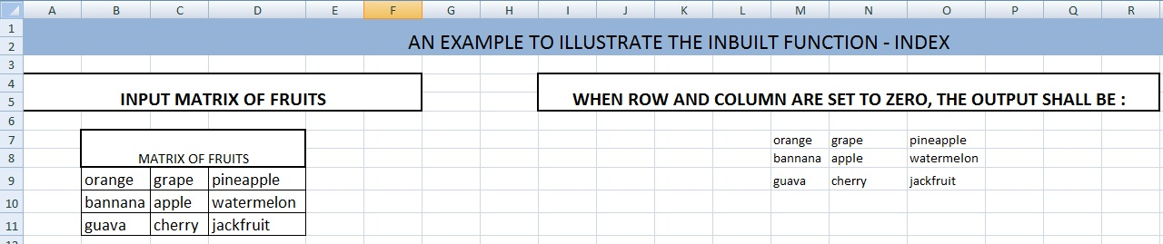
Fig 2.3.11: Index example (step 3)

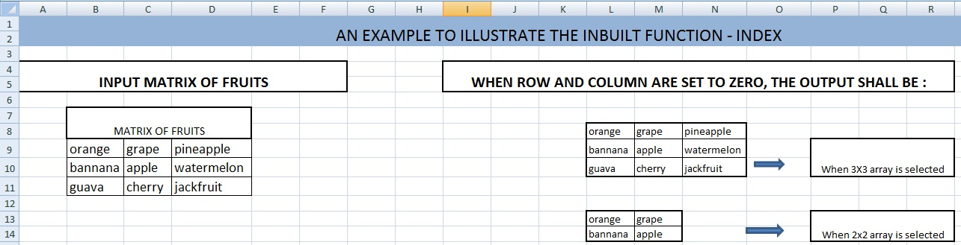
Fig 2.3.12: Index example (output)
In the case, where only a 2X2 matrix is selected rather than a 3x3 matrix to represent the output, then only the upper 2x2 part of the input matrix shall be displayed. The figure 2.3.12 shows both the 3x3 and 2x2 matrix outputs. For further details on INDEX function and its implementation please refer to the EXCEL help.
- VLOOKUP
‘VLOOKUP’ or vertical lookup is an inbuilt function in MS Excel classified under the ‘lookup and reference’ functions. VLOOKUP holds a great importance, as it is possible to extract the value of a certain location in a table array. This location in the table array is given by the row corresponding to the row of the lookup element or search tag and the column is given by the user input column number. The search tag and the column number are given as user arguments to the inbuilt function.
THE SYNTAX OF VLOOKUP
VLOOKUP (lookup_value, table_array, col_index_num, range_lookup)
Here the lookup value is the search term or tag which is searched within the range of the table array. The table_array refers to the table array provided by the user and refers to the range of cells within which the lookup_value provided has to be searched and its corresponding row has to be ascertained. The next argument ‘col_index_num’ is the column number which the user desires. The output of the VLOOKUP function shall thus be the value at the location given by the row of the lookup_value or tag in the table and the user inputted column number
Consider the following example. We have a database featuring the admission number, marks, attendance and conduct of different students. Now using this database, we have to create an instant reference solution such that, when the student admission number is given, the entire details of the student including the attendance, marks and conduct should be displayed. The example shows a small database and the instant reference for such a database seems illogical, but it shall become logical once size of the database becomes too large to be manually searched.
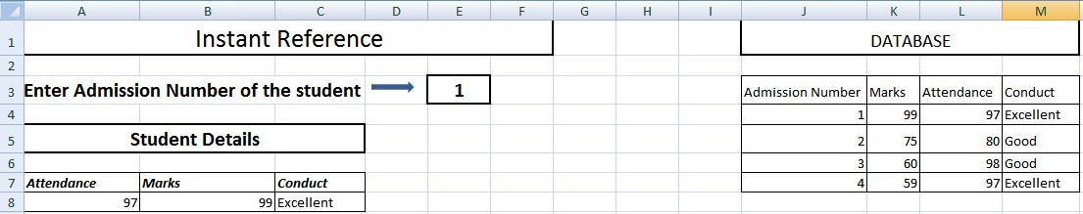
Figure 2.3.13: Vlookup example

The instant reference is created by using the VLOOKUP function. Here the admission number given in the cell ‘E3’ (refer figure 2.3.13 ) acts as the lookup_value or tag to be searched in the database. The range of cells forming the database (excluding all captions) forms the table_array. The col_index_num is the user inputted value for the desired column to be looked up. As we can see, the ‘Admission Number’ column is the first column in the database or table_array, followed by ‘Marks’ column and then by ‘Attendance’ column and finally by the ‘Conduct’ column. Thus, in order to obtain the attendance details of a student of certain admission number using the instant reference, we use the following formula VLOOKUP (E3, $J$4:$M$7, 3), where ‘E3’ is the admission number of the student whose details has to be looked up, $J$4:$M$7 is the range of cell comprising of the entire database, and ‘3’ refers to the ‘col_index_num’ for the attendance column, since it comes third in the database.
The last argument as per the syntax is the range_lookup and it is an optional logical value which if set to ‘TRUE’ shall return the exact or approximately exact solution. In case the exact value is not found, the next largest value less than the given lookup_value is considered. If this option is set to ‘FALSE’, the ‘VLOOKUP’ function shall only return exact matches and avoids approximation. By default, this option is set to ‘TRUE’. For further information on VLOOKUP please consult the EXCEL help.

- Matrix Operations
Matrix operations are one of the most constantly used features and MS Excel supports matrix operations like Multiplication , Inversion and transposing using the functions ‘MMULT’, ‘MINVERSE’ and ‘TRANSPOSE’ respectively. For all array operations in excel, to apply the same formula across the cell ranges of an array, we perform the following operation:
Step 1: Select the cell range in which the common formula has to be applied.
Step 2: After selection, type in the formula required in the first cell of the selected range of cells.
Step 3: Press the keyboard keys Control (Ctrl) + Shift + Enter, one after the other, so that the formula entered in the first cell shall be applied across the selected range.
We have to perform the above operation for each of the matrix operations we perform.
4.1 Matrix Multiplication
The function in MS Excel for matrix multiplication is MMULT and its syntax is given as follows:
MMULT (array1, array2)
According to matrix multiplication, if two matrix arrays ‘A’ and ‘B’ were to be multiplied, then the number of column in A should be equal to the number of rows in B. If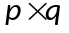was the order of A and 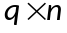 was the order of matrix B then the resulting product matrix would have the order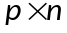.
We consider the two matrix multiplication examples in excel, one with rectangular matrix and the other with non-rectangular matrix. In the first example, we use two 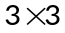matrixes to get our product matrix. The product matrix also would be of the order. Hence, we select a cell range of order and apply a formula, say, 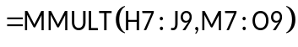where H7:J9 represents the first matrix cell ranges, and M7:O9 represents the second matrix cell range. In the second example, we take two non-rectangular matrices of the order 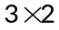and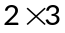. Here also the product matrix is of the order. Hence we select a cell range and apply the MMULT formula by giving the cell ranges of the non-rectangular matrices as the parameters. The same method can be used to calculate any matrix product. The following figure illustrates the same.
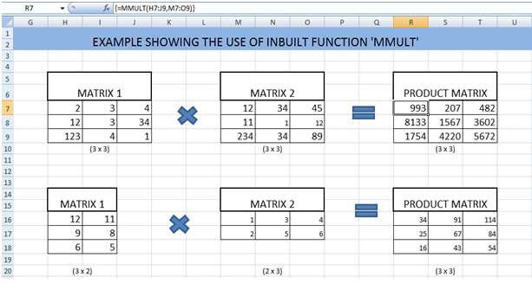
Fig 2.3.14: Matrix multiplication

  - Matrix Inversion
The matrix inversion is done in MS Excel using the in-built function MINVERSE and it takes the cell ranges of a single array or matrix as is its parameter. We illustrate the example of finding an inverse of a matrix. To find the inverse of the matrix we select a cell range, since the inverse will have the same order as the original matrix, and in the first cell of the selected range we give the formula , say, 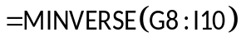where G8:I10 represents the cell range containing the original matrix. Then we press Ctrl+Shift+Enter so as that the formula is applied across the selected range and thus we obtain the inverse matrix. The following screenshot illustrates the inversion.
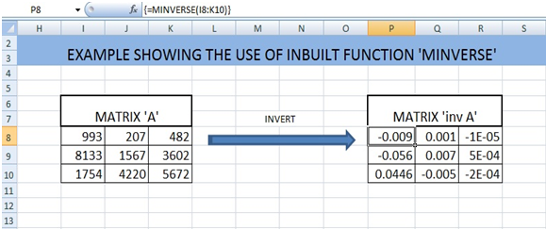
Fig 2.3.15: Matrix Inversion
4.3 Matrix Transpose
The matrix transpose is done in MS Excel using the in-built function TRANSPOSE and it takes the cell ranges of a single array or matrix as is its parameter. We illustrate the example of finding the transpose of a matrix. To find the transpose of the matrix we select a cell range, since the transpose will have the same order as the original matrix, and in the first cell of the selected range we give the formula , say, 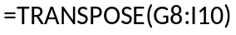where G8:I10 represents the cell range containing the original matrix. Then we press Ctrl+Shift+Enter so as that the formula is applied across the selected range and thus we obtain the transposed matrix. The following screenshot illustrates the transposing. For further information on the inbuilt EXCEL functions please consult the EXCEL help.
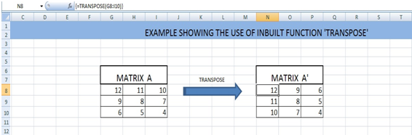
Fig 2.3.16: Matrix transposing

  - What if analysis
2.4.1 Introduction
In general, What-if analysis [1] is the process of changing the values in cells to see how those changes will affect the outcome of formulas on the worksheet. There are three kinds of what-if analysis tools that comes with Excel: scenarios, data tables, and Goal Seek. Scenarios and data tables take sets of input values and determine possible results. A data table works only with one or two variables, but it can accept many different values for those variables. A scenario can have multiple variables, but it can accommodate only up to 32 values. Goal Seek works differently from scenarios and data tables in that it takes a result and determines possible input values that produce that result. In this book, we used only ‘data table’ option of the what if Analysis
For plotting 2-variable function, we visualize the working of Data-Table option of what-IF analysis is as follows: In two cells we give values for two variables. Then in a third cell, based on the cell references of these values, we show excel (through a formula) how to compute the function value. Further on, we tell excel-engine to compute function values for various combinations of variables based on the example we have shown. For this we need to prepare a rectangular array in which in the top row, we show the values of one variable and in the left-most column of the table we show the values of other variable. In essence, we show excel the computation required for function evaluation based on the two variable values and then ask Excel to do it for various other combinations. These types of requirement happen frequently in business. At first we show an example from business (banking).
- Monthly payment amount calculation (Bank loan)
As mentioned above, we should show one example-computation to Excel Engine and indicate values of variables for which same computation is to be repeated. The required format is explained through an example. The example is taken from the material by Bill Jelen [2]. Take the case where you want to buy a car, and want to compare four price points and four loan terms to calculate the monthly payment amount.
Step 1: Enter the loan information data in excel sheet as said in the following figure 2.4.1
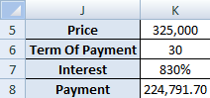
Fig 2.4.1: Data (loan data)
The interest is given as 830% which is much more than usual rate (after all we are showing an example to excel). The Payment is calculated with the PMT formula as =PMT(K7/12,K6,-K5). PMT is a built in function provided in excel. Now what we require is a table of various prices and terms of payment.
Step 2: Enter the prices in C5 to F5 and terms of payment in B6 to B9. The final table (B5:F9) will look as shown in the figure 2.4.2. Note that computation of payment is done in cell B5 which is the intersection cell of the row and column in which we have entered price and term of payment values.
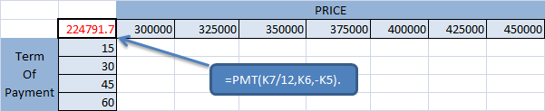
Fig 2.4.2 :Table preparation for What-IF Analysis

Now look for What-if option in “Data” Tab of menu bar in Microsoft excel 2007. If it is not there, you will have to enable it. The following figure 2.4.3 illustrates how to enable it in Excel 2010. Older versions of Excel also follow a similar process. From the File menu select Options or Excel Options etc.
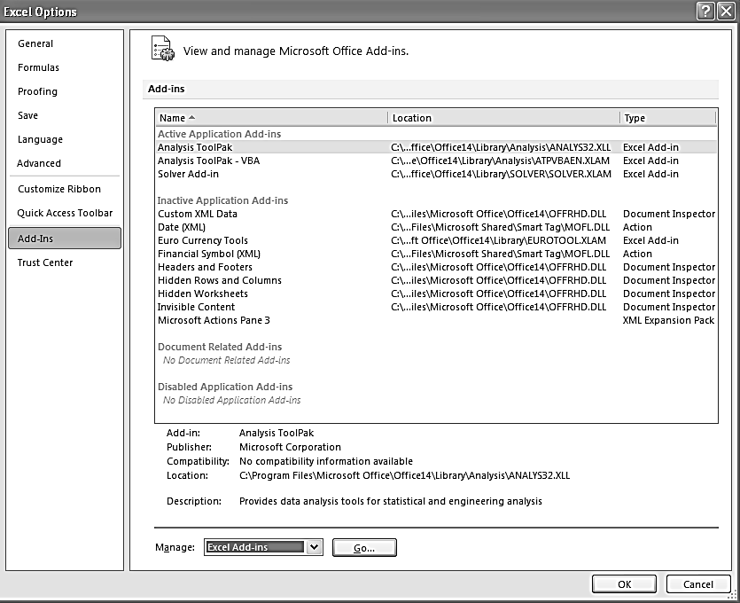
Fig 2.4.3: Dialog box for enabling Excel-add-ins

From the Excel Options Dialog, select the Add-Ins option and you can see Excel Add-Ins List at the bottom. Click Go and ‘Add-Ins’ dialog opens. Tick “Analysis ToolPak” option from this dialog and click “OK”. The illustration is in the figure 2.4.4.
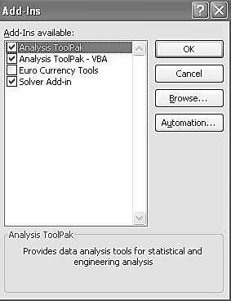
Fig 2.4.4: Selection of “Analysis Toolpack”
This enables the What-If analysis option in the Data menu. Now select the data table as shown in figure 2.4.5 and select the What-If analysis option from Data menu and then select the Data table option from it. Figure 2.4.5 says it all.
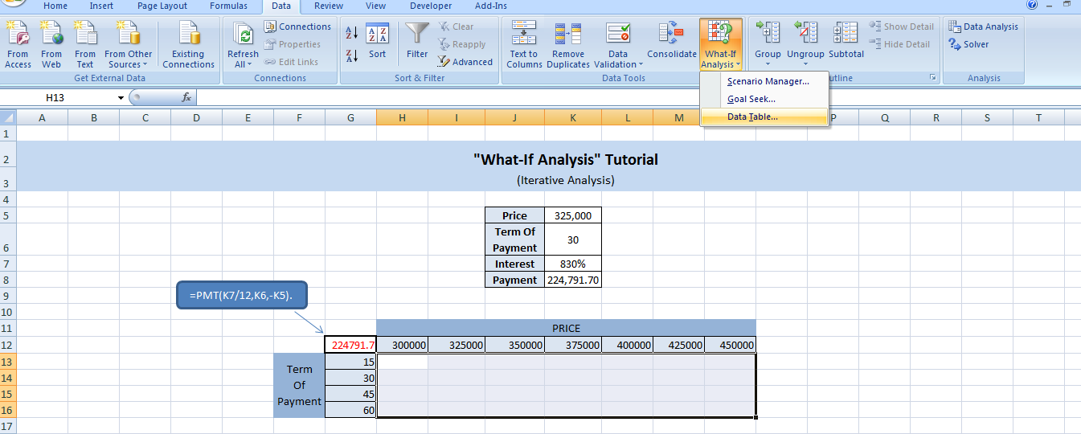
Fig 2.4.5: Selecting data table

On selecting the “Data Table” option shown in the figure 2.4.5, Data Table dialog appears.. Now enter the Row input cell as $K$5 (which is the address of the cells showing “Term of Payment”) and enter the column input cells as $K$6 (which is address of the cells showing “Price”).
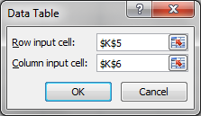
Fig 2.4.6: “Data Table” Window

Click OK and it fill the data table with the calculated value. The formula in the cell B5 will change its value when any cell B2 to B4 changes. What-If analysis changes B2 and B3 and the changed value in B5 are put onto the intersection of the corresponding row and column. The result looks like the figure 2.4.7.
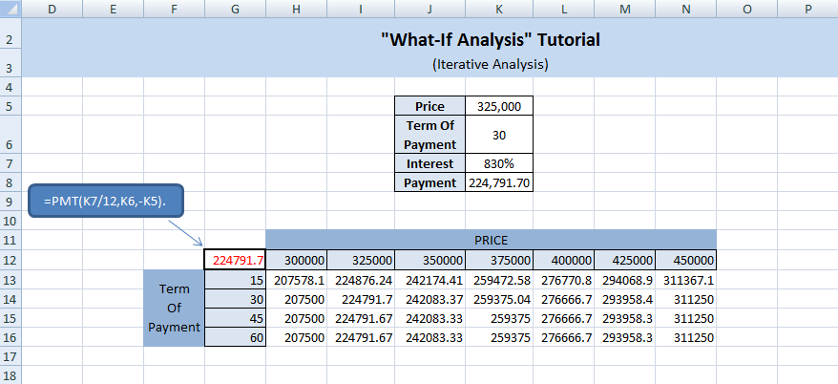
Fig 2.4.7: Output of What-If Analysis

Note that the table is computed for different values of price and term of payment. Interest rate for all the combination is 830%. Now if we change this to 8.3 (by entering 8.3 in cell B4), the computed values in the table changes according to the new interest rate.
2. Plotting 2D graphs using “What-If Analysis”
Have you ever tried to visualize a mathematical function? A visualization of a function helps one to understand about how it varies over the domain. Excel provides with it a lot of data visualization options. Let’s now try to one of them. This time we will use “What-If Analysis” to visualize a function. Consider the function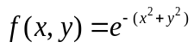. The output of this function depends on the variables x and y. To keep things simple let us assume a closed set for x and y variables i.e. X= [-5 +5] and Y= [-5 +5].
Step 1: Type all values of the set X and Y as shown in figure 2.4.8.
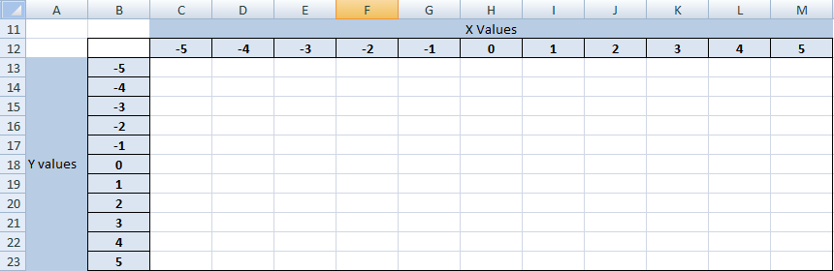
Fig 2.4.8: What-If Analysis table format setup

Step 2: Our next objective is to obtain function output for all the possible values of x and y. For doing it using “What-If Analysis” there are certain pre-requisites to be done. Label two cells as X and Y, and type the formulas to get the first X value and first Y value on corresponding cells. This is described through the figure 2.4.9.
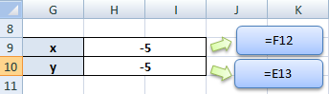
Fig 2.4.9 :What-If Analysis prerequisite

Step 3: Now go to “Data” tab in Excel and click on “What-If Analysis”. (“What-If Analysis” is feature available with Microsoft Excel 2007 or later versions)
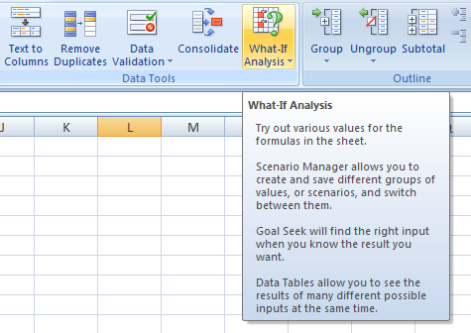
Fig 2.4.10: What-If Analysis (located in data menu bar)

Step 4: The previous process will end up in a small window labeled “Data Table” as shown in figure 2.4.11. For our case enter the Row input cell as $H$9 and the Column input cell as $HS10.Now click on “Ok”
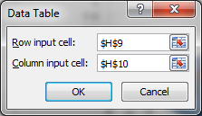
Fig 2.4.11: What-If Analysis (details input box)

Now we will get the cell values for all the combinations of X and Y. This is shown in the figure 2.4.12.
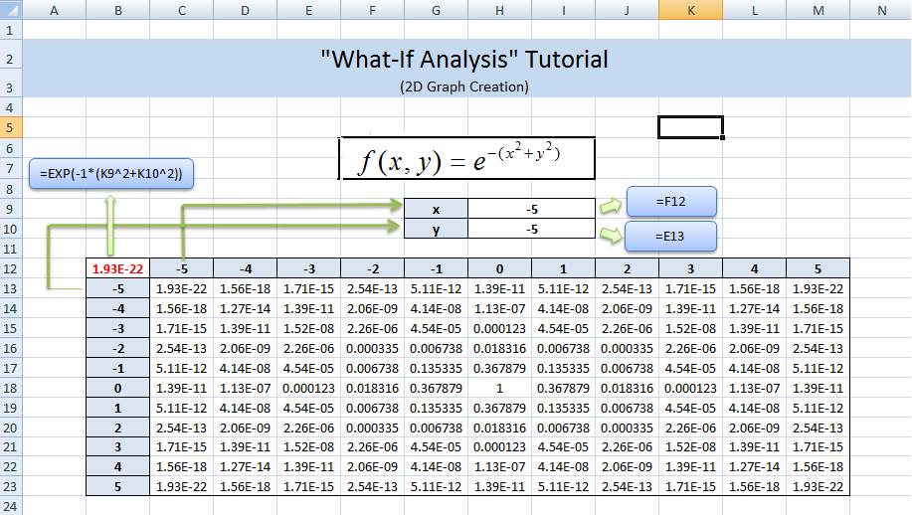
Fig 2.4.12:What-If Analysis Result

Step 5: Now select the range of cells from C13 to M23 and obtain the surface plot (Surface plot feature is available in the “Insert” Tab on Excel 2007)
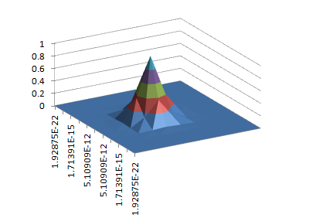
Fig 2.4.13: Surface plot of data

Now we have the “3D surface plot” of the function, for the range [-5 +5] for both X and Y. This is the visualization we were talking about. Seeing the plot one will be able to tell how many minima’s/maximal’s the function has”? What is over all shape of the function? etc. Note that the surface plot in figure 2.4.13 is not smooth because we have generated only a small rectangular array of values for plotting.

2.5 Solver and Optimization
2.5.1 Introduction
We are living in a world of speed and precision. And it is a fact that optimization is the driving force behind this. Many of the problems we face today require optimizing certain quantities. Scheduling of programs to be executed by computers, code optimization by a compiler, minimization of chip area for VLSI chips, a Robotics path planning problem, financial Risk management etc. are examples of this kind of problem. Because of the practical importance of optimization, it has been studied extensively and the research continues for faster solutions for many of the tougher problems.
Today online business is on a boom due to the role of search engine optimizers and due to this, Internet marketing companies are receiving lots of attention. Search Engine optimization is the process of improving your sites ranking in search engines so that your website appears on first page of search engines result for specific largely searched keywords. There are some other key factors included in search engine optimization that play a important role in website ranking like search engine marketing, link building, website analysis and organic search engine [1].
A study on aircraft design concluded that, a plane can achieve maximum range if it has a design, where virtually all the volume of the plane is contained in the wing. Designing Stealth included an optimization problem which aimed at maximizing the volume at its wings [4].

- (b)
(a) Stealth bomber (b) Aspects in Search Engine Optimization.
Fig 2.5.1

The new age managers in a company depend on the latest technologies to assist them in taking decisions. You will be surprised to know that Microsoft Excel is one of the most popular tools used for data analysis and decision making in modern industries.
Solvers, or optimizers, are software tools that help users find the best way to allocate scarce resources. The resources may be raw materials, machine time or people time, money, or anything else in limited supply. The "best" or optimal solution may mean maximizing profits, minimizing costs, or achieving the best possible quality. An almost infinite variety of problems can be tackled this way, some of such real industrial problems are as follows:
- Finance and Investment
Working capital management involves allocating cash to different purposes (accounts receivable, inventory, etc.) across multiple time periods, to maximize interest earnings.
Capital budgeting involves allocating funds to projects that initially consume cash but later generate cash, to maximize a firm's return on capital.
Portfolio optimization which aim at creating efficient portfolios, involves allocating funds to stocks or bonds to maximize return for a given level of risk, or to minimize risk for a target rate of return.
- Manufacturing
In industries, job scheduling involves allocating time for work orders on different types of production equipment, to minimize delivery time or maximize equipment utilization.
Blending (of petroleum products, ores, animal feed, etc.) involves allocating and combining raw materials of different types and grades, to meet demand while minimizing costs.
Cutting stock (for lumber, paper, etc.) involves allocating space on large sheets or timbers to be cut into smaller pieces, to meet demand while minimizing waste.

Distribution and Networks
Routing (of goods, natural gas, electricity, digital data, etc.) involves allocating something to different paths through which it can move to various destinations, to minimize costs or maximize throughput.
Loading (of trucks, rail cars, etc.) involves allocating space in vehicles to items of different sizes so as to minimize wasted or unused space.
Scheduling of everything from workers to vehicles and meeting rooms involves allocating capacity to various tasks in order to meet demand while minimizing overall costs.
2.5.2 Adding Solver To Excel:
To use Excel to solve problems the Solver add-in must be included. Typically this feature is not installed by default when Excel is first setup on your hard disk. To add this facility to your menu you need to carry out the following steps (once-only):

- Click the Microsoft Office Button , and then click Excel Options.
- Click Add-Ins, and then in the Manage box, select Excel Add-ins.
- Click Go.
- In the Add-Ins available box, select the Solver Add-in check box, and then click OK.
- After you load the Solver Add-in, the Solver command is available in the Analysis group on the Data tab (Fig 2.5.2).
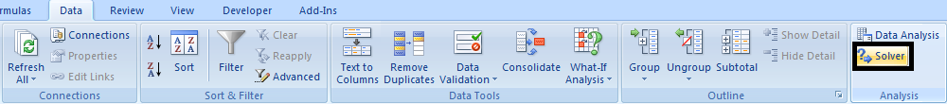
Figure 2.5.2: Microsoft excel menu bar
2.5.3 Using Solver:
To use a solver, you must build a model that specifies:
- The resources to be used, using decision variables,
- The limits on resource usage, called constraints, and
- The measure to optimize, called the objective.
The solver will find values for the decision variables that satisfy the constraints while optimizing (maximizing or minimizing) the objective function.
Spreadsheets such as Microsoft Excel provide a convenient way to build such a model. Anyone who has used a spreadsheet is already familiar with the process: Cells on a worksheet can hold numbers, labels, or formulas that calculate new values -- such as the objective function of an optimization. Constraints are simply limits (specified with <=, = or >= relations) on formula cells. And the decision variables are simply input cells containing numbers. Solver is a tool for solving such optimization models [2].
Optimization problems can be solved using any programs written in languages such as C or C++ or platform like Matlab. The choice of approach is up to you. Spreadsheets offer a quick way to build a model, and you can easily explain the model and its results to other users who are spreadsheet-literate. Application programs in Visual Basic, C/C++ or other languages may offer higher performance and may be easier to distribute widely, within a company or to commercial users.

2.5.4 Defining the Model:

Identify the following things for the problem you are going to solve using solver:
- Decision Variables
- Objective Function
- Constraints
A solver deals with numbers, so you'll need to quantify the various elements of your model: decision variables, constraints, and the objective -- and their relationships.

Decision Variables: Start with the decision variables. They usually measure the amounts of resources, such as money, to be allocated to some purpose, or the level of some activity, such as the number of products to be manufactured, the number of pounds or gallons of a chemical to be blended, etc.
If you are shipping goods from, say, 3 different plants to 5 different warehouses, there are 3 x 5 = 15 different routes along which products could be shipped. So, you might have 15 variables, each one measuring the number of products shipped along that route.
You might also have 4 different product types, and you might want to plan shipments in each of the next 6 months. So this might lead to 3 x 4 x 5 x 6 = 360 variables. This illustrates how a model can become large rather quickly! Part of the art of modeling is deciding how much detail is really required; for example, you might not need to explicitly measure shipments of different product types [6].

Objective Function: Once you've defined the decision variables, the next step is to define the objective, which is normally some function that depends on the variables. For example, suppose you were planning how many units to manufacture of three products: TV sets, stereos, and speakers. Your objective might be to maximize profit, so assume that each TV set yields a profit of $75, each stereo $50, and each speaker $35. Then your objective function might be:
75 * TV sets + 50 * Stereos + 35 * Speakers
On a spreadsheet where the number of TV sets, stereos and speakers are in cells D9, E9 and F9 respectively, the formula would be:
= 75*D9 + 50*E9 + 35*F9
Constraints: Constraints reflect real-world limits on variables such as production capacity, market demand, available funds, and so on. This in turn limits the values of decision variables. Constraints on resources are expressed in terms of functions of decision variables.
General Constraints. For example, if A1:A5 contains the percentage of funds to be invested in each of 5 stocks, you might use B1 to calculate =SUM(A1:A5), and then define a constraint B1 = 1 in the solver dialog box to say that the percentages allocated must sum up to 100%.
Bounds on Variables. Of course, you can also place a limit directly on a decision variable, such as A1 <= 100. Upper and lower bounds on the variables are efficiently handled by most optimizers and are very useful in many problems.

Policy Constraints. Some constraints are determined by policies that you or your organization may set. For example, in an investment portfolio optimization, you might have a limit on the maximum percentage of funds to be invested in any one stock, or one industry group.

Physical Constraints. Many constraints are determined by the physical nature of the problem. For example, if your decision variables measure the number of products of different types that you plan to manufacture, producing a negative number of products would make no sense. This type of non-negativity constraint is very common. Although it may be obvious to you, constraints such as A1 >= 0 must be stated explicitly, because the solver has no other way to know that negative values are disallowed.
As another example of a physically determined constraint, suppose you are modeling product shipments in and out of a warehouse over time. You'll probably need a balance constraint, which specifies that, in each time period, the beginning inventory plus the products received minus the products shipped out equals the ending inventory -- and hence the beginning inventory for the next period.

Integer Constraints. Advanced optimization software also allows you to specify constraints that require decision variables to assume only integer (whole number) values at the solution. If you are scheduling a fleet of trucks, for example, a solution that called for a fraction of a truck to travel a certain route would not be useful. Integer constraints normally can be applied only to decision variables, not to quantities calculated from them.
A particularly useful type of integer constraint specifies that a variable must have an integer value with a lower bound of 0, and upper bound of 1. This forces the variable to be either 0 or 1 -- nothing in between -- at the final solution. Hence, it can be used to model "yes/no" decisions.
For example, you might use a 0-1 or binary integer variable to represent a decision on whether to lease a new machine. Your model might then calculate a fixed lease cost per month, but also a lower cost per item processed with the machine, if it is used. A solver can help determine whether leasing the machine will yield higher or lower profits.
2.5.5 The Solution Interpretation:
A solution (set of values for the decision variables) for which all of the constraints in the Solver model are satisfied is called a feasible solution. Most solution algorithms first try to find a feasible solution, and then try to improve it by finding another feasible solution that increases the value of the objective function (when maximizing, or decreases it when minimizing). An optimal solution is a feasible solution where the objective function reaches a maximum (or minimum) value.
A globally optimal solution is one where there are no other feasible solutions with better objective function values. A locally optimal solution is one where there are no other feasible solutions "in the vicinity" with better objective function values -- you can picture this as a point at the top of a "peak" or at the bottom of a "valley" which may be formed by the objective function and/or the constraints. The Solver is designed to find optimal solutions -- ideally the global optimum -- but this is not always possible. In many cases, though, you may be happy to find a good solution -- one that is better than the solution you are using now.
Whether the Solver can find a globally optimal solution, a locally optimal solution, or a good solution depends on the nature of the mathematical relationship between the variables and the objective function and constraints (and the solution algorithm used).

2.5.6 Model Solving:
Solver models can be easy or hard to solve. "Hard" models may require a great deal of CPU time and random-access memory (RAM) to solve -- if they can be solved at all. The good news is that, with today's very fast PCs and advanced optimization software available, a very broad range of models can be solved.
Three major factors interact to determine how difficult it will be to find an optimal solution to a solver model:
- The mathematical relationships between the objective function and constraints, and the decision variables.
- The size of the model (number of decision variables and constraints) and its sparsity.
- The use of integer variables - memory and solution time may rise exponentially as you add more integer variables

2.5.7 Mathematical Relationships:

Linear programming problems

Smooth nonlinear optimization problems

Global optimization problems

Non-smooth optimization problems
The types of mathematical relationships in a model (for example, linear or nonlinear) determine how hard it is to solve, and the confidence you can have that the solution is truly optimal. These relationships also have a direct bearing on the maximum size of models that can be realistically solved.
A model that consists of mostly linear relationships but a few nonlinear relationships generally must be solved with more "expensive" nonlinear optimization methods. The same is true of models with mostly linear or smooth nonlinear relationships, but a few non-smooth relationships. Hence, a single IF or CHOOSE function that depends on the variables can turn a simple linear model into an extremely difficult or even unsolvable non-smooth model.
A few advanced solvers can break down a problem into linear, smooth nonlinear and non-smooth parts and apply the most appropriate method to each part -- but in general, you should try to keep the mathematical relationships in a model as simple (i.e. close to linear) as possible.
Linear programming problems -- where all of the relationships are linear -- can be solved up to hundreds of thousands of variables and constraints, given enough memory and time. Models with tens of thousands of variables and constraints can be solved in minutes (sometimes in seconds) on modern PCs. You can have very high confidence that the solutions obtained are globally optimal.
Linear programming (LP) is one of the most widely applied O.R. techniques and owes its popularity principally to George Dantzig's simplex method (Dantzig 1963) and the revolution in computing. It is a very powerful technique for solving allocation problems and has become a standard tool for many businesses and organizations. Although Danzig's simplex method allows solutions to be generated by hand, the iterative nature of producing solutions is so tedious that had the computer never been invented then linear programming would have remained an interesting academic idea, relegated to the mathematics classroom. Fortunately, computers were invented and as they have become so powerful for so little cost, linear programming has become possibly one of the most widespread uses for a personal PC.
There are of course numerous software packages which are dedicated to solving linear programs (and other types of mathematical program), of which possibly MATLAB, Mathematica, LP Solve, LINDO, GAMS and XPRESS-MP are the most popular. In recent years, however, several standard business packages, such as spreadsheets, have started to include an LP solving option, and Microsoft Excel is no exception. The inclusion of an LP solving capability into applications such as Excel is attractive for at least two reasons. Firstly, Excel is perhaps the most popular spreadsheet used in business and as such is very accessible. Second to this, the spreadsheet offers very convenient data entry and editing features, which allows greater understanding of how to construct linear programs.
Smooth nonlinear optimization problems -- where all of the relationships are smooth functions (i.e. functions whose derivatives are continuous) -- can be solved up to tens of thousands of variables and constraints, given enough memory and time. Models with thousands of variables and constraints can often be solved in minutes on modern PCs. You can have reasonable confidence that the solutions obtained are locally optimal, but not globally optimal.
Global optimization problems -- smooth nonlinear optimization problems where a globally optimal solution is sought -- can often be solved up to a few hundred variables and constraints, given enough memory and time. Depending on the solution method, you can have reasonably high confidence that the solutions obtained are globally optimal.
Non-smooth optimization problems -- where the relationships may include functions like IF, CHOOSE, LOOKUP and the like -- can be solved up to scores, and occasionally up to hundreds of variables and constraints, given enough memory and time. You can only have confidence that the solutions obtained are "good" (i.e. better than many alternative solutions) -- they are not guaranteed to be globally or even locally optimal.

2.5.8 Model Size:
The number of decision variables and the number of constraints it contains measure the size of a solver model.
Most optimization software algorithms have a practical upper limit on the size of models they can handle, due to either memory requirements or numerical stability. This is true even if the vendor doesn't set a limit, or claims that the software can handle "problems of unlimited size." Solver engine’s decision variables range up to 2000 and other advanced engines have much higher limits. Number of decision variables solver can handle depends on whether the problem is linear or non linear.

Sparsity: Most large solver models are sparse. This means that, while there may be thousands of decision variables and thousands of constraints, the typical constraint depends on only a small subset of the variables. For example, a linear programming model with 10,000 variables and 10,000 constraints could have a "coefficient matrix" with 10,000 x 10,000 = 100 million elements, but in practice, the number of nonzero elements is likely to be closer to 2 million.
For example, a solver engine that created a coefficient matrix for all 100 million elements in the problem above would likely need 800 megabytes of RAM just to hold the matrix and it would take a great deal of CPU time to process this huge matrix. Instead, Solver creates a sparse data structure for a factorized matrix that might require 24 megabytes for the above problem, and would proceed to solve it far more quickly, with greater numerical accuracy.

Integer Variables: Integer variables (i.e. decision variables that are constrained to have integer values at the solution) in a model make that model far more difficult to solve. Memory and solution time may rise exponentially as you add more integer variables.
This is because many combinations of specific integer values for the variables must be tested, and each test requires the solution of a "normal" linear or nonlinear optimization problem. The number of combinations can rise exponentially with the size of the problem. "Branch and bound" and "branch and cut" strategies help to cut down on this exponential growth, but even with these strategies, solutions for even moderately large mixed-integer programming (MIP) problems can require a great deal of time.
Different formulations of the same model with integer variables can take radically different amounts of time to solve. With such models, expert-consulting help with the formulation may make the difference between an easily solvable and a practically unsolvable model. With a well-designed formulation, it is often possible to solve linear programming problems with hundreds, or even thousands of integer variables in a modest amount of time.

2.5.9 Step-By-Step Approach:

Essential Steps: To define an optimization model, you'll follow these essential steps:
- Choose a spreadsheet cell, or a variable in your program, to hold the value of each decision variable in your model.
- Create a spreadsheet formula in a cell, or an assignment statement in a program function, that calculates the objective function in your model.
- Similarly, create formulas in cells, or assignment statements in a program function, to calculate the left hand sides of your constraints.
- Use the dialogs in Excel, or function calls in your program, to tell the Solver about your decision variables, objective and constraint calculations, and desired bounds on constraints and variables.
- Click Solve in Excel to find the optimal solution.
Within this overall structure, you have a great deal of flexibility, either in a spreadsheet or in a custom program, in how you choose cells or variables to hold your model's decision variables and constraints, and which formulas and built-in functions you use. Since decision variables and constraints usually come in groups, you'll want to use cell ranges in your spreadsheet, or arrays in your program to represent them.

2.5.10 Optimization Problem Types:

Linear Programming (LP)

Quadratic Programming (QP)

Solving LP and QP Problems

Other Problem Types

Linear Programming (LP) Problems: A linear programming (LP) problem is one in which the objective and all of the constraints are linear functions of the decision variables. An example of a linear function is:
75 x₁ + 50 x₂ + 35 x₃
where x₁, x₂ and x₃ are decision variables. The variables are multiplied by coefficients (75, 50 and 35 above) that are constant in the optimization problem; they can be computed by your Excel worksheet or custom program, as long as they don't depend on the decision variables.
Linear programming problems are intrinsically easier to solve than nonlinear (NLP) problems. In an NLP there may be more than one feasible region and the optimal solution might be found at any point within any such region. In contrast, an LP has at most one feasible region with “flat faces” (i.e. no curves) on its outer surface, and the optimal solution will always be found at a “corner point” on the surface where the constraints intersect.
This means that an LP Solver needs to consider many fewer points than an NLP Solver, and it is always possible to determine (subject to the limitations of finite precision computer arithmetic) that an LP problem (i) has no feasible solution, (ii) has an unbounded objective, or (iii) has a globally optimal solution (either a single point or multiple equivalent points along a line).

Quadratic Programming (QP) Problems: A quadratic programming (QP) problem has an objective that is a quadratic function of the decision variables, and constraints which are all linear functions of the variables. An example of a quadratic function is:
2 x₁² + 3 x₂² + 4 x₁ x₂
where x₁, x₂ and x₃ are decision variables. A widely used QP problem is the Markowitz mean-variance portfolio optimization problem, where the quadratic objective is the portfolio variance (sum of the variances and co variances of individual securities), and the linear constraints specify a lower bound for portfolio return.
QP problems, like LP problems, have only one feasible region with "flat faces" on its surface (due to the linear constraints), but the optimal solution may be found anywhere within the region or on its surface.
A QP's quadratic objective has an algebraic property of definiteness. The "best" quadratics are positive definite (in a minimization problem) or negative definite (in a maximization problem). You can picture the graph of these functions as having a "round bowl" shape with a single bottom (or top). Portfolio optimization problems are usually of this type.
A semi-definite quadratic has bowl shape with a "trough" where many points have the same objective value. An indefinite quadratic has a "saddle" shape, but its true minimum or maximum is not found in the "interior" of the function but on its boundaries with the constraints, where there may be many locally optimal points. Optimizing an indefinite quadratic function is a difficult global optimization problem, and is outside the scope of most specialized quadratic solvers.

Solving LP and QP Problems: LP problems are usually solved via the Simplex method. This method, originally developed by Dantzig in 1948, has been dramatically enhanced in the last decade, using advanced methods from numerical linear algebra. This has made it possible to solve LP problems with up to hundreds of thousands -- sometimes millions -- of decision variables and constraints.
An alternative to the Simplex method, called the Interior Point or Newton-Barrier method, was developed by Karmarkar in 1984. Also in the last decade, this method has been dramatically enhanced with advanced linear algebra methods so that it is often competitive with the Simplex method, especially on very large problems.
Since a QP problem is a special case of a smooth nonlinear problem, it can be solved by a smooth nonlinear optimization method such as the GRG or SQP method. However, a faster and more reliable way to solve a QP problem is to use an extension of the Simplex method or an extension of the Interior Point or Barrier method.
Technology Solver Uses:

The standard Microsoft Excel Solver uses a basic implementation of the primal Simplex method to solve LP problems. It is limited to 200 decision variables. It uses the Generalized Reduced Gradient (GRG2) for solving smooth non linear problems. The Excel 2010 solver includes newer algorithms called Evolutionary Solver to solve non-linear problems. The new Evolution solver accepts Solver models defined in exactly the same way as the Simplex and GRG Solvers, but uses genetic algorithms to find its solutions. While the Simplex and GRG solvers are used for linear and smooth nonlinear problems, the Evolutionary Solver can be used for any Excel formulas or functions, even when they are not linear or smooth nonlinear.

Below are some higher end versions of solver which are not available by default in Excel but can be purchased from Frontline System, Inc (Solver developers):-
The Premium Solver uses an improved primal Simplex method with two-sided bounds on the variables. It handles up to 1,000 decision variables. The Premium Solver Platform uses an extended LP/Quadratic version of this Simplex Solver to handle problems of up to 2,000 decision variables. It optionally uses a dual Simplex method to solve LP subproblems in a mixed-integer (MIP) problem. However, this Simplex algorithm does not exploit sparsity in the model.
The Large-Scale LP Solver for the Premium Solver Platform uses a more sophisticated implementation of the Simplex method, which fully exploits sparsity in the LP model to save time and memory. It creates an LU factorization of the LP matrix and uses the Bartels-Golub update, steepest-edge pivoting strategies, and dynamic Markowitz refactorization. The basic version of this Solver engine handles up to 16,000 decision variables, and the extended version handles up to 65,000 variables.
The XPRESS Solver Engine uses a state-of-the-art implementation of the primal and dual Simplex method, with all the methods of the Large-Scale LP Solver plus many more strategies for matrix updating and refactorization, multiple and partial pricing and pivoting, and strategies for overcoming degeneracy. Its dual Simplex method is probably the best in the world. The XPRESS Solver engine handles up to 200,000 decision variables.

Active Set Method: The Large-Scale SQP Solver for the Premium Solver Platform uses a state-of-the-art implementation of an active set method for solving linear (and quadratic) programming problems, which fully exploits sparsity in the model to save time and memory, and uses modern matrix factorization methods for numerical stability. The Large-Scale SQP Solver handles problems of up to 100,000 variables and 100,000 constraints.

Interior Point or Newton-Barrier Method: The XPRESS Solver Engine uses a state-of-the-art implementation of the primal-dual path-following Interior Point or Newton-Barrier method, based on Mehrotra's predictor-corrector algorithm. It includes high performance linear algebra methods for the normal equations matrix and advanced ordering algorithms for factorizing this matrix.
The XPRESS Solver engine is capable of "crossing over" from the Newton-Barrier method to the Simplex method near the optimal solution, in order to generate sensitivity analysis information.

Quadratic Programming: As noted above, the Premium Solver Platform uses an extended LP/Quadratic version of the Simplex method with bounds on the variables to handle LP and QP problems of up to 2,000 decision variables. This solver is capable of finding optimal solutions for positive definite or semi-definite quadratic objectives (when minimizing; negative definite or semi-definite when maximizing).
Also as noted above, the Large-Scale SQP Solver uses a state-of-the-art implementation of a sparsity-exploiting active set method for solving quadratic programming (QP) problems. It is especially effective on difficult QP problems.
The XPRESS Solver engine uses the natural extension of the Interior Point or Newton-Barrier method to solve QP problems. It is able to solve extremely large quadratic programming problems, if sufficient memory is available. However, it is appropriate only for positive definite quadratic objectives (when minimizing; negative definite when maximizing).

2.6 Solving Simple Optimization Problems in MS-Excel

Example 1: Imagine that you are managing a factory that is building three products: TV sets, stereos and speakers. Each product is assembled from parts in inventory, and there are five types of parts: Chassis, picture tubes, speaker cones, power supplies and electronics units. Your goal is to produce the mix of products that will maximize profits, given the inventory of products on hand.
From this description, we can see that the decision variables are the number of products to build, and the objective function will be (gross) profit. Assume that you can sell TV sets for a gross profit of $75 each, stereos for a profit of $50 each, and speaker cones for $35 each.
To assemble a TV set, you need 1 chassis, 1 picture tube, 2 speaker cones, 1 power supply and 2 sets of electronics. To make a stereo, you need 1 chassis, 2 speaker cones, 1 power supply and 1 set of electronics. And to build a speaker, all you need is 1 speaker cone and 1 set of electronics. The parts you have on hand are 450 chassis, 250 picture tubes, 800 speaker cones, 450 power supplies and 600 sets of electronics. This defines the constraints in this problem: You can build only a limited number of products from the parts on hand.

Writing the Formulas: Before we implement this problem statement in Excel let's write out formulas corresponding to the verbal description above. If we temporarily use the symbol x₁ for the number of TV sets assembled, x₂ for the number of stereos, and x₃ for the number of speakers, our total profit is:
Maximize 75 x₁ + 50 x₂ + 35 x₃ (Profit) 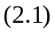
Building each product requires a certain number of parts of each type. For example, TV sets and stereos each require one chassis, but speakers don't use one. The number of parts used depends on the mix of products built (the left hand side of each constraint), and we have a limited number of parts of each type on hand (the corresponding constraint right hand side):
Subject to:
1 x₁ + 1 x₂ + 0 x₃ <= 450 (Chassis) 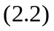
1 x₁ + 0 x₂ + 0 x₃ <= 250 (Picture tubes)
2 x₁ + 2 x₂ + 1 x₃ <= 800 (Speaker cones)
1 x₁ + 1 x₂ + 0 x₃ <= 450 (Power supplies)
2 x₁ + 1 x₂ + 1 x₃ <= 600 (Electronics)
Notice that we've expressed each constraint in a uniform way: Where we aren't using any parts of a particular type, we just use a quantity of 0 parts. This will make it easier to define the constraints in cell ranges in Excel, and calculate their values using a function like SUMPRODUCT in Excel or a simple FOR loop in VB.
Since the number of products built cannot be negative, we'll also have lower bounds on the variables:
x₁, x₂, x₃ >= 0. 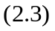
Now we'll see step-by-step implementation of Solver model, in Excel. (See PRODUCT MIX.xls available in attached CD)

Creating an Excel Worksheet: Assuming that you have Microsoft Excel, and the standard Excel Solver installed, the next step is to create a worksheet where the formulas for the objective function and the constraints are calculated. In the worksheet below, we have reserved cells D4, D5 and D6 to hold our decision variables x₁, x₂ and x₃: The number of TV sets, stereos and speakers to build.
The profit margin for each assembled product ($75, $50 and $35) is shown in cells C4, C5 and C6. This allows us to compute the objective function in cell I14 as:
=SUMPRODUCT(C4:C6,D4:D6)
In the table area C14:G16, we've entered the number of parts of each type needed to assemble each finished product. For example, the 2 at E14 means that we need 2 speaker cones to build a TV set. These numbers come directly from the formulas for the constraints shown earlier. With these values in place, we can enter a single formula at cell H4:
=SUMPRODUCT(C14:C16,$D$4:$D$6)
To compute the total number of chassis used for any given number of TV sets, stereos and speakers. Then we can copy this formula to cells C12:C15 to compute the total number of parts used of all the other types.
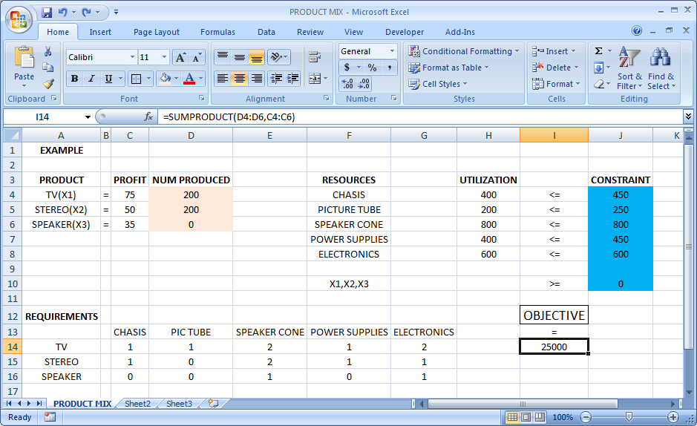
Fig 2.6.1: Product Mix Example Output
In cells J4:J8, we've entered the number of parts we have in inventory of each type. This allows us to express the constraints shown earlier as:
H4:H8 <= J4:J8
This is a shorthand for H4 <= J4, H5 <= J5, and so on through H8 <= J8. We can enter this form directly in the Solver dialogs. We will also enter the constraint:
D4:D6>0 to require the decision variables to have non-negative values.

Using the Solver Dialogs: To let the Solver know which cells on the worksheet represent the decision variables, constraints and objective function, we select Tools Solver... in Excel, which displays the Solver Parameters dialog. In the Set Target Cell edit box, we type or click on cell J14, the objective function. By Checking Equal To as Max. In the By Changing Cells edit box, we type D4:F6 or select these cells with the mouse.
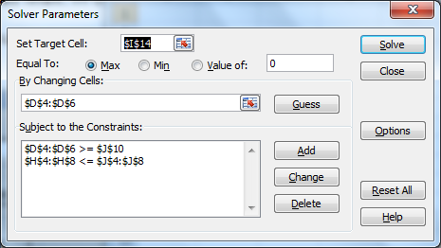
Fig 2.6.2: Completely entered solver box looks like this

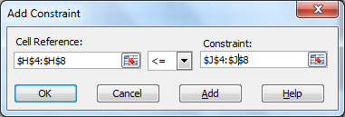
Fig 2.6.3: Constraint Dialog Box
To add the constraints, we click on the Add button, select cells H4:H8 in the Cell Reference edit box (the left hand side), and select cells J4:J8 in the Constraint edit box (the right hand side); the default relation <= is OK (Refer Fig 2.6.3). We choose the Add button again (either from the dialog above, or from the main Solver Parameters dialog) to define the nonegativity constraint on the decision variables.
- Finding and Using the Solution: To find the optimal solution, we simply click on the Solve button. After a moment, the Solver returns the optimal solution: 200 in cells D4 and D5, and 0 in cell D6. This means that we should build 200 TV sets, 200 stereos and no speakers, to earn a total profit of $25,000 (shown at cell J14).

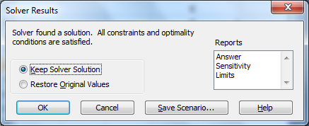

Fig 2.6.4: Solver Results

The message "Solver found a solution" appears in the Solver Results dialog, as shown here. We now click on "Answer" in the Reports list box to produce an Answer Report, and click OK to keep the optimal solution values in cells D4:D6(Fig 2.6.4).
This report shows the original and final values of the objective function (target cell) and the decision variables (adjustable cells), as well as the status of each constraint at the optimal solution. Notice that the constraints on speaker cones and electronics are binding and have a slack value of 0: We used up all of the parts of these two types in building 200 TV sets and 200 stereos, but there were 50 units of each of the other parts left over. If we could obtain additional speaker cones and electronics, we could further increase total profits, but extra units of the other parts would not help in the short run.
This was an example of a linear programming problem. Other types of optimization problems may involve quadratic programming, mixed-integer programming, constraint programming, smooth nonlinear optimization, global optimization, and no smooth optimization.

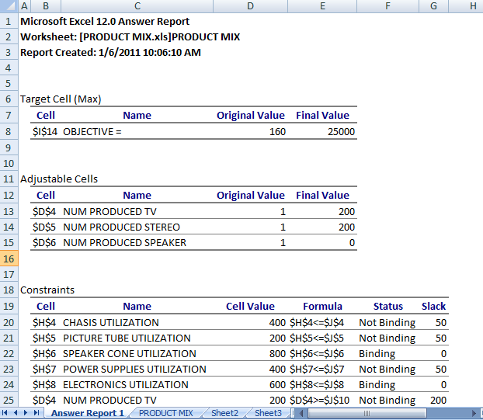
Fig 2.6.5: Answer Report
Microsoft Excel includes a workbook, Solvsamp.xls in the Office\Samples folder where you can find more samples.
- Example 2: A carpenter makes tables and chairs. Each table can be sold for a profit of £30 and each chair for a profit of £10. The carpenter can afford to spend up to 40 hours per week working and takes six hours to make a table and three hours to make a chair. Customer demand requires that he makes at least three times as many chairs as tables. Tables take up four times as much storage space as chairs and there is room for at most four tables each week. What should be the number of Tables and chairs to be made so that carpenter gets the maximum profit?
- High School Method:
First of all we need to figure out what are the variables that we are interested in. This case it is nothing but the number of chairs and tables. Now let us assume X_{T} number of tables made per week and X_{C} number of chairs made per week
Objective Funtion
Maximize 30x_{T} + 10x_{C} 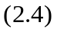

Constraints

Total Work Done: 6x_{T} + 3x_{C} <= 40 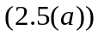

Customer Demand: x_{C} >= 3x_{T} 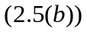

Storage Space: (x_{C}/4) + x_{T} <= 4 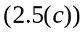

All Variables >=0
The graphical representation of the problem is given in figure 2.6.6 and from that we have that the solution lies at the intersection of (x_{C}/4) + x_{T} = 4 and 6x_{T} + 3x_{C} = 40
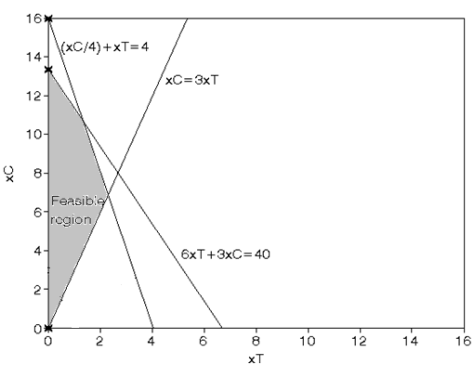
Fig 2.6.6: Plot of constraints
Solving equations and simultaneously we get X_{C} = 10.667, X_{T} = 1.333 and the corresponding profit = £146.667.
- “Solver” way of tacking the problem
Let us now approach this problem using Excel. Figure 2.6.7 shows the Carpenter.xls where we have formulated the problem.
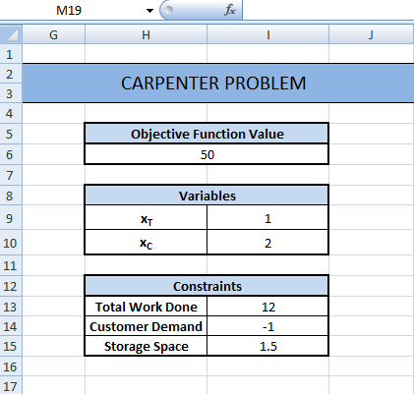
Fig 2.6.7: Problem representation in Excel
The Objective function is given in cell B11 with the formula =30*C1+10*C2. Now run Solver and fill all the necessary fields as shown in Figure 2.6.8. The decision variables are stored in cells C1 and C2. We have four Constraints. The formulas used are:-
Work Done: = 6*C1+3*C2
Customer Demand: = C2-3*C1 (Since X_{C} >= 3X_{T} => X_{C} - 3 X_{T} >= 0)
Storage Space: = C2/4+C1
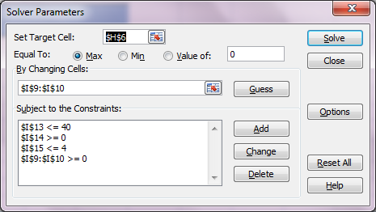
Fig 2.6.8: Solver parameters
Once you click Solve you will get the correct solution in a matter of seconds. It can be seen that the optimal values of variables X_{T} (number of tables) and X_{C} (number of chairs) is obtained. In this case the carpenter has to produce 1.3 chairs and 10.6 tables to get a maximum profit. [If the carpenter is stubborn enough and does not leave a chair in partial completion state for a day, he can round of to 1 chair and 11 tables at the cost of his profit.)
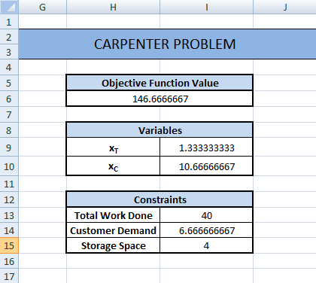
Fig 2.6.9: Optimal solution
- Example 3: We want to construct a box whose base length is 3 times the base width. The material used to build the top and bottom cost $10/ft2 and the material used to build the sides cost $6/ft2. If the box must have a volume of 50ft3 determine the dimensions that will minimize the cost to build the box.
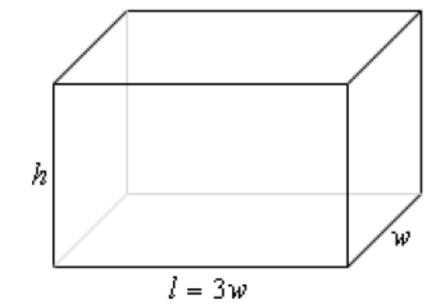
Fig 2.6.10: Box to be built

We want to minimize the cost of the materials subject to the constraint that the volume must be 50ft3. Note as well that the cost for each side is just the area of that side times the appropriate cost.
The problem can be formulated as:-
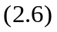
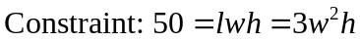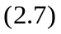
Solving these two equations 2.6 and 2.7 simultaneously we get W = 1.88 X_{T} = 4.70 and the corresponding profit = 637.59.
- “Solver” way of tacking the problem
Remember the above problem is a non-linear optimization problem and excel 2007 uses GRG method to provide solution. It is may not always be global optimal solution. You may have to change the initial solution to get better solution. For this problem we started with 1 as the initial solution and got correct answer as w=1.8ft and h=4.7ft.
To solve it in Excel we need to express the objective function in using an excel formula as shown in the figure 2.6.11. (See cell H6). Provide random values for w and h.
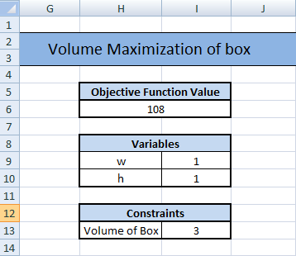
Fig 2.6.11: Problem representation in Excel
As the next step take the “Solver” in Excel and assign the Target cell as $H$6, where we have the objective function. Now provide the constraint equations as $I$13 =50. Provide the changeable cells as $I$9:$I$10 the changing cells. This is shown in the figure 2.6.12.
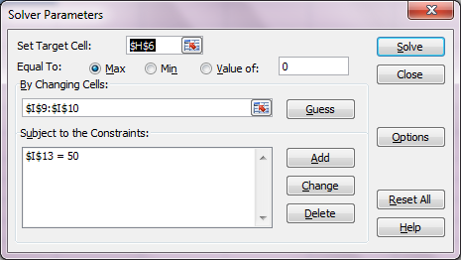
Fig 2.6.12: Solver parameters

On clicking “OK” the solver will provide the optimal value of w and h for which the holding capicity of the box becomes maximum. For our case the optimal value of w is 1.88 ft and the optimal value of h is 4.7 ft. [See that solver gave the same solution as what we obtianed through the first method]
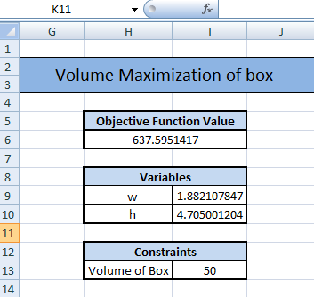
Fig 2.6.13: Optimal solution

- Example 4: We all would have tried the make a box out of a cardboard in our childhood. All we had to do is to cut out a square block from all the edges of the cardboard and fold the edges. Now let’s try to do that again. This time we have made the cutting length better so that the box which is created has to have a maximum holding capacity (volume). This can be done using optimization methods. Assume we have a piece of cardboard that is 14 inches by 10 inches and we have to cut out the corners as shown in figure 2.6.14 and fold up the sides to form a box.
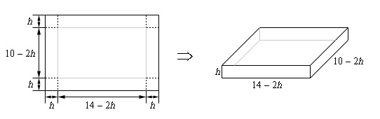
Fig 2.6.14
Desired box
- High school method:
In this example, this time, we’ve run into a problem where the constraint doesn’t really have an equation. This just means is that we have one less equation to worry about. This case you will see that there are two possible solutions. This is where our logic has to play its role. I.e. To solve this problem we should have at least one constraint which enables us to select the right solution.
We know that the volume of the box is given by l*b*h. And this case we want to maximize the volume. Here is the volume, in terms of h and its first derivative.
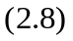
It is a known fact that for any function the maximum or minimum value point will have its slope as 0. So we go for finding the derivative for the equation 2.8 i.e.
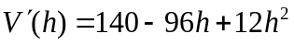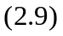
Setting the first derivative equal to zero and solving gives the following two critical points,
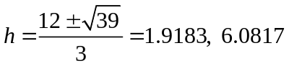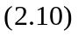
Now we are in a dilemma! This is where we apply our logic. Here we have two critical points and we’ll need to determine which one is the value we need. In this case, this is easier than it looks. We know that the squares are cut from all the edges. Go back to the figure given (fig 2.6.14) in the problem statement and notice that we can quite easily find limits on h. The smallest h can be is 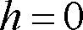 even though this doesn’t make much sense as we won’t get a box in this case. Also from the 10 inch side we can see that the largest h can be is although again, this doesn’t make much sense physically. So, knowing that whatever h is it must be in the range we can see that the second critical point is outside this range and so the only critical point that we need to worry about is 1.9183. Finally, since the volume is defined and continuous on all we need to do is plug in the critical points and endpoints into the volume to determine which gives the largest volume. Here are those function evaluations.
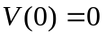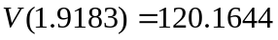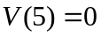
The above proof makes it clear that, if we take 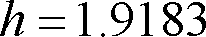 we get a maximum volume.
- “Solver” way of optimizing
We have already seen how to frame the equations and constraints for the problem. To solve it in Excel we need to express the objective function in using an excel formula as shown in the figure 2.6.15. (See cell I7). Assign a random “h” value.
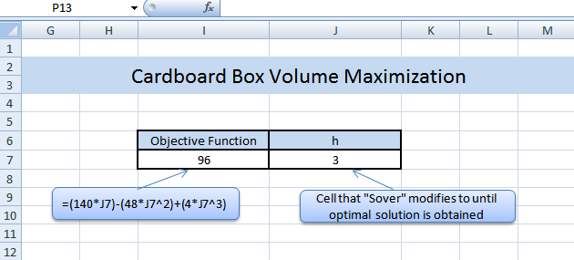
Fig 2.6.15: Problem representation in Excel

Now we have our objective function represented in Excel. As the next step take the “Solver” in Excel and assign the Target cell as $I$7. Now provide the constraints equations as $J$7 <=5 and $J$7 >=0. Since the variable in the objective function is dependent on the value of h we need to give $J$7 as the changing cells. (The objective function takes the value of h from the cell J7)
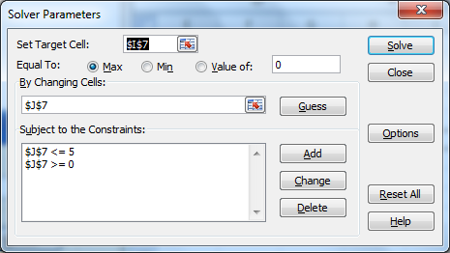
Fig 2.6.16: Solver parameters

On solving we will get the optimal function output as 120 at h= 1.9183. Remember that, the same output was obtained when we solved it with the first method.
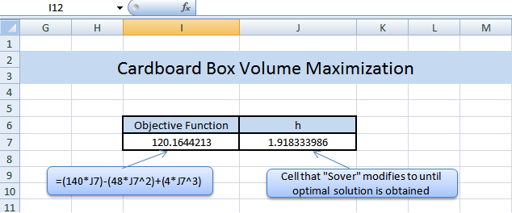
Fig 2.6.17: Optimal solution

- Example 5: This time our objective is the profit maximization for BHARAT PETROLEUM. The firm produces two main products: Petrol and Kerosene. The firm has a contract with a raw material (crude oil) supplier, calling for the delivery of 200 units of the given raw material during the forthcoming period. It is true that raw material must be used during the period and that none can be carried over to the next period in inventory. Furthermore, Petrol requires 20 units of the crude oil to produce one unit of output and Kerosene requires 40 units of crude oil to produce one unit of output.
- High school method:
Let’s assume Q1 the quantity of petrol produces and Q2 be the quantity of kerosene produced. Thus the constrained optimization problem can be formulated as follows.
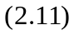
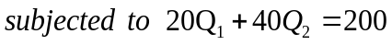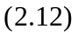
To makes things easy we can first draw the plot the above two equations (the objective function and the constraint equation). The objective function (profit function) is a curve, for it consists of terms having order two and the constraint is a line, for it has only linear terms. It is sure that the solution our problem will lie in points where the curve intersects with the line. Now let’s plot it.
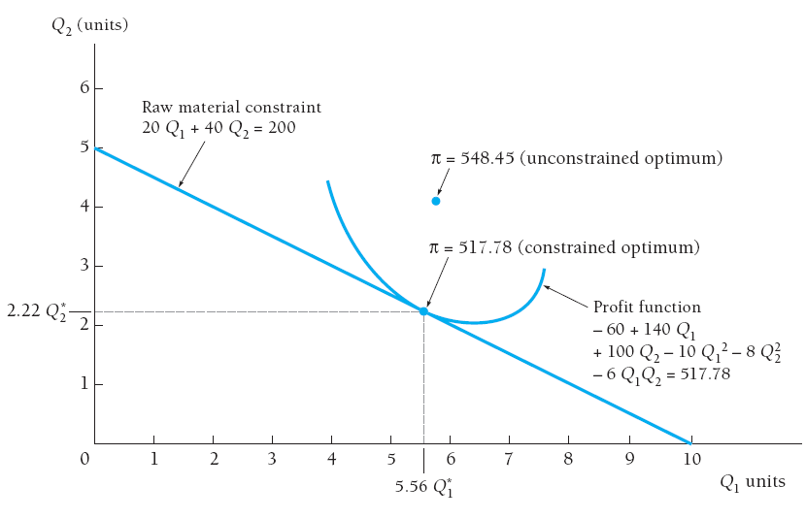
Fig 2.6.18: Plot of Objective Function & constraints

The raw material constraint line and the profit function (curve) that is tangent to the constraint line are shown together in the figure 2.6.18. Following the below procedure, we can solve for Q1 ad Q2.
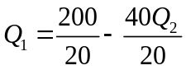
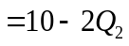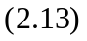

Substituting this expression for Q1 in the objective function, we obtain the following

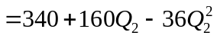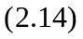
Taking the derivative of this expression with respect to Q2 yields
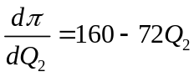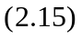
Setting 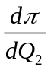 equal to zero and solving for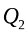, we obtain
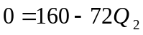
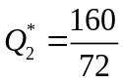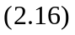
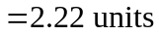
In turn solving for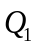, we obtain

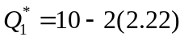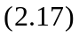
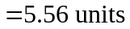

Thus 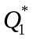 = 5.56 and 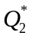=2.22 is the optimal solution to the constrained profit maximization problem.

Using the constraint to substitute for one of the variables in the objective function, will yield an optimal solution only when there is one constraint equation and it is possible to solve this equation for one of the decision variables. With more than one constraint equation and/or a complex constraint relationship, the more powerful method of Lagrangian multipliers can be employed to solve the constrained optimization problem.

- “Solver” way of optimizing

We have already seen how to frame the equations and constraints for the problem. To solve it in Excel we need to express the objective function in using an excel formula as shown in the figure 2.6.19. (See cell I7). Provide random values for Q1 and Q2.
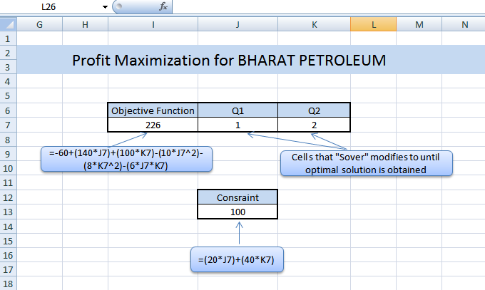
Fig 2.6.19: Problem representation in Excel

Now we have our objective function represented in Excel. As the next step take the “Solver” in Excel and assign the Target cell as $I$7. Now provide the constraint equations as $J$13 =200. Provide the changeable cells as $J$7:$K$7 the changing cells. (The objective function takes the value of h from the cell J7)
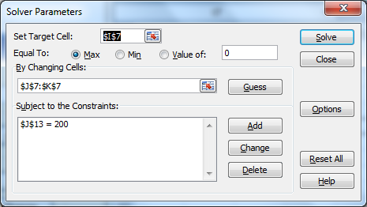
Fig 2.6.20: Solver parameters

On solving we will get the optimal function output at Q1 = 5.555 and Q2 = 2.22. Remember that, the same output was obtained when we solved it with the first method. Figure 2.6.21 shows the optimal solution obtained after solving.
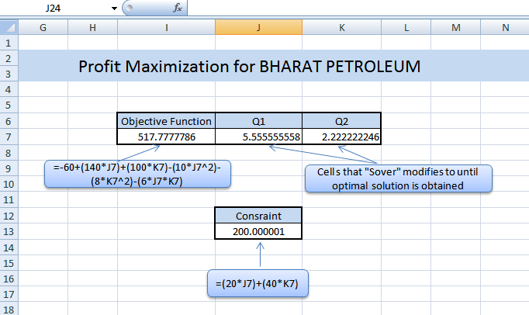
Fig 2.6.21: Optimal solution

2.7 Solving Management Problems in Excel

- Example 1: IP InfoTech Pvt Ltd. is a software firm which operated all over the world. It does projects on developing billing solutions. There was a sudden demand for completing four kinds of jobs (A-D) for which seven employees were selected. The project manager identified that each person takes different time to do different jobs. It is shown in table 2.7.1 where each cell corresponds to the number of hours taken by a person to do a particular job. As a project manager you have to decide the lowest duration of time required to do all the jobs and also take care that no person is assigned more than one job.
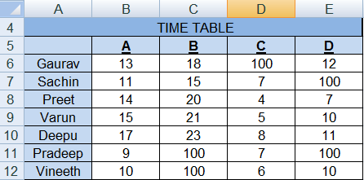
Table 2.7.1: Time Allocation Table
Solution: The problem that we mentioned is called an assignment problem where we have to find an optimal assignment to jobs\machines without assigning an agent more than once and ensuring that all jobs are completed. It is a kind of problem which occurs generally in the modern industries.
Formulation of the problem
The main objective here is to reduce the total time taken for completing all the jobs. Let 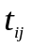be the time taken by 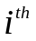person to do the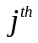job.
Let 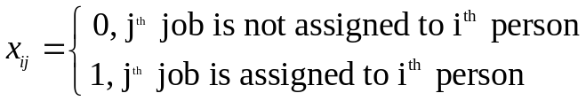
Hence the total time required to complete all the jobs is
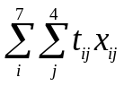. 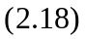
There are two constraints for the problem. First one is that either a person is assigned a job or not assigned a job. It is given as in equation 2.19:
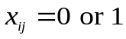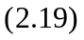
The second constraint is that each job must be completed and not more than one person to be assigned same job. It is given as in equation 2.20:
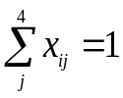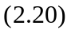
Now we have formulated the problem, let us see how it is done in excel and solved using Solver add in figure. 2.7.1 shows the actual time allocation table of ABC solution. Readers can refer the excel file at For CD\Excel Basics\ Personnel Assignment Machine.xlsx. The input table showing the time allocation is given from B6:E12.
Fig 2.7.1: Time Allocation Table
In figure 2.7.2, the assignment table showing which job is assigned to which person is given at H6:K12. The cells in this table can have a value either 1 or 0.
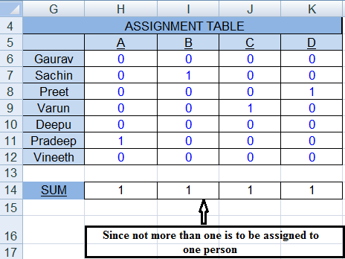
Fig 2.7.2: Job Assignment table
To calculate the total time required to complete all the jobs, we find out the individual time required by each person to do the job he is assigned to. The sum of time across all the persons will give the total time required. Please note that since we have seven persons and four jobs, there will be three people sitting idle. Column N6:N12 shows the time required by each person given a particular assignment table. We have used the excel function SUMPRODUCT, giving the parameters from assignment table of a particular person along with the corresponding time duration for doing him all the jobs.
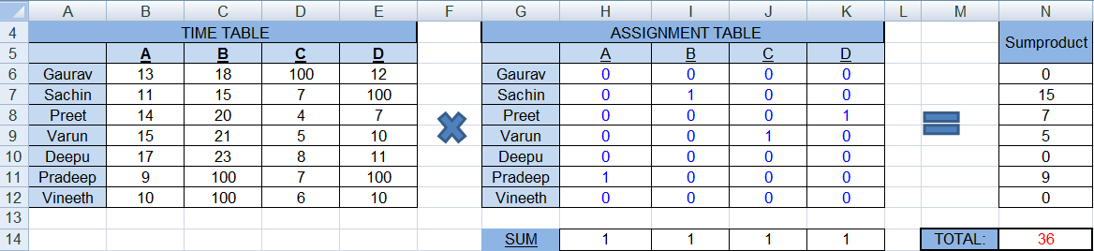
Fig 2.7.3: Overall process

Hence for Gaurav the formula is =SUMPRODUCT(B6:E12,H6:K12). You can drag it to get for each person. The total time will be the sum the individual time durations. Cell N14 holds this value with formula as =SUM(N6:N12). Let us now open solver and provide it with the objective function and constraints. This entire process is shown in Figure 2.7.3.
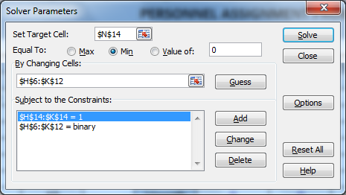
Fig 2.7.4: Solver parameters
Figure. 2.7.4 shows the solver and the required parameters. The target cell is set as N14 which contains the sum of all time durations. Equal To field is made as Min since we need to minimize the total time duration. The changing cell is set to the assignment table H6:K12. As we discussed that there are two constraints. For the first constraint, we make the assignment table as binary. For this add the cell reference of assignment table and select ‘bin’ from the drop down and click add button. Figure. 2.7.5 explains this.
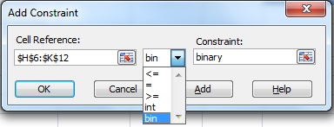
Fig 2.7.5: Adding first constraint
For adding the second constraint, in excel sheet we have created a row H14:K14 which hold the summation value of each column of assignment table. We will add a constraint which makes the sum value to be 1. This will ensure that all jobs are assigned and each job is assigned only to one person. Figure. 2.7.6 shows the adding of the second constraint.
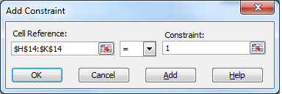
Fig 2.7.6: Adding Second constraint
Once all these parameters are fed to the solver, we can run it and obtain the solution in assignment table. The time duration obtained in cell N14 will show minimum amount of total time required.
- Example 2: Employee hiring has always remained a management level problem since the start of industrial revolution. The problem we are going to discuss here is, one such faced by Shanti Niketan hospital. This hospital always has a requirement for hiring nurse and they usually hired on a weekly basis. The hospital has access to seven categories of nurses [A to G - Full time and Part time]. The hospital wanted to hire nurses from these categories such that daily requirement of nurses as specified in the table (see figure 2.7.7) are met. At the same time the hospital has to reduce its cost of hiring (The cost for nurses belonging to each of the categories are shown in Figure 2.7.8). Also we are provided with the staff allocation table in Figure 2.7.9 which shows the working days of each category of nurse. So, find the optimal number of nurses from the available categories which satisfies the nurse requirement for each day by minimizing the hiring cost.

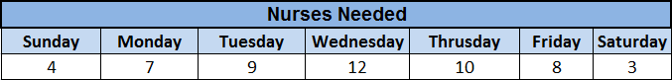
Fig 2.7.7: Weekly requirements of nurses
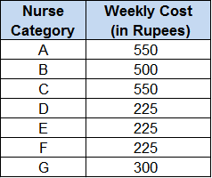
Fig 2.7.8: Nurse hiring cost
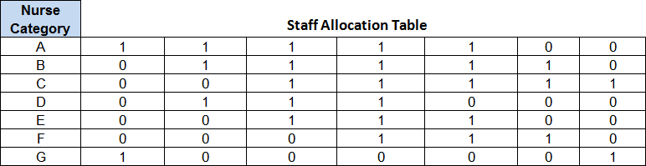
Fig 2.7.9: Staff Allocation Table
We need to find the total number of nurses required in each category so that it fulfills the requirement of nurses each day and also reduces the total hiring cost. Let us see how this is formulated and solved in excel. Figure 2.7.10 shows the entire process.
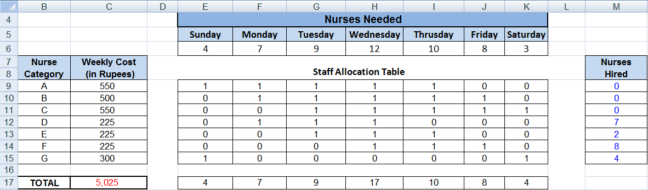
Fig 2.7.10: Overall process
Our aim is to find the optimum allocation of nurses in the hospital and minimize the total hiring cost per week. Hence we created a column Nurse hired (M9:M15) where we will find the optimum allocation of nurses. We have calculated the total cost by finding the SUMPRODUCT function between Nurses hired column (M9:M15) and their weekly cost (C9:C15) and stored it in cell C17. There are three constraints for this problem. The first constraint is that the total number of nurses hired in each category should be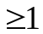. This is done since we don’t require any negative number in the hiring column. The second constraint is that the total number of nurses hired on a particular day should be to the actual requirement of nurses on that day. For this we created a row E17:K17 which calculates the total number of nurses allocated on each day. We again used SUMPRODUCT function between the column of the staff allocation table (E9:E15 for Sunday) and the Nurses hired column (M9:M15). The last constraint is to make Nurse hiring column integer so that we don’t get the count in decimals.
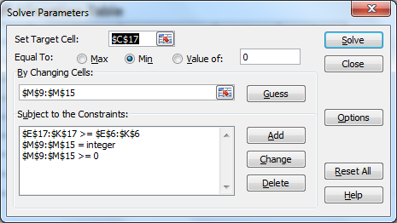
Fig 2.7.11: Solver parameters
Figure 2.7.11 shows the solver and the required parameters as per the above explanation. Column C17 is set as target cell which we need to minimize. The Equal to field is set as Min. Changing Cells are set as the Nurse Hired column (M9:M15). All the three constraints are set in the constraints field. Once you have run the solver, you can see the optimum weekly nurse hiring combination for which the cost is minimum.
- Example 3: Consider yourself as an Admin Manager of a major shopping mall in the city. One of your major responsibilities is to appoint smart customer executives for helping the customers in their shopping. Since the inflow of the customers to the mall differs in each period of the day, the requirement of the executives also varies accordingly. This information is given Figure. 2.7.12. There are 15 schedules which comes under two categories. Executives can be either in full time schedule for which they have to work for 7 hours/day or part time schedules for which they work for 4 hours/day. These 15 schedules differ in the time slots allocated as shown in Figure 2.7.13. Here we have shown 4 schedules under full time category and 11 schedules under part time category. As an admin manager you have to hire the optimum number of executives in each of the 15 schedules, ensuring the minimum requirement people required in each time period of the day. Here the objective function is to minimize the count of people hired subject to the constraints.
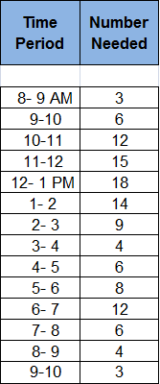
Fig 2.7.12: Number of executive required in each period of day
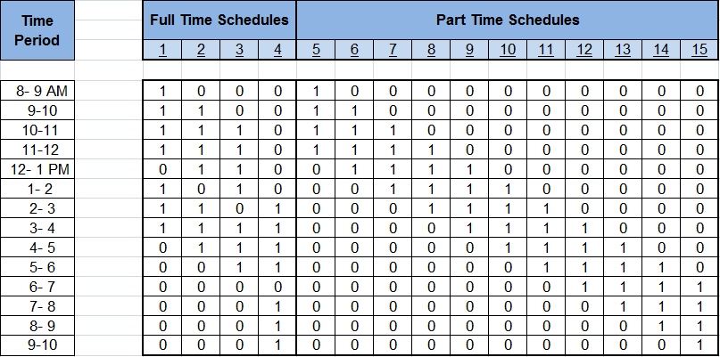
Fig 2.7.13: Time slots for each schedule.
Figure 2.7.14 shows the entire formulation done and solved using excel.
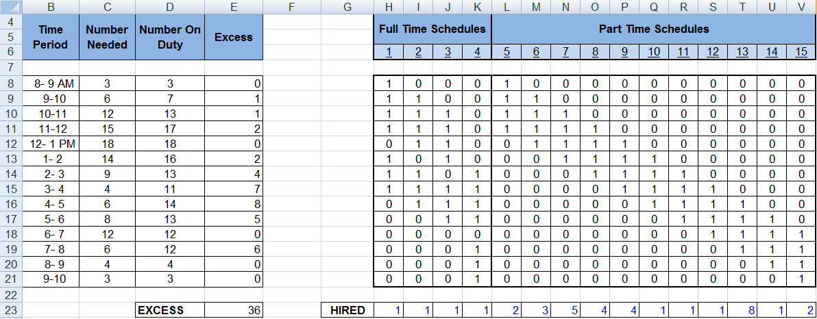
Fig 2.7.14: Overall process
You can see that we have added a row from H23:V23 showing the hiring count from each schedule. This is what we have to find. The column Number on Duty (D8:D21) is calculated by taking the SUMPRODUCT of hired row with the corresponding row of time slots table. That means for 8-9 AM the number on duty cell will contain the formula =SUMPRODUCT(H$23:V$23,H8:V8). The column Excess contains the excess count of people assigned to each time period. Hence it contains the formula =D8-C8 which subtracts the number needed column with the actual number on duty. The point to note is that the excess should never go in negative which means insufficient number of people. The sum of excess count from each time period is put in cell E23 which is to be minimized. As a whole there are three constraints for this problem. The first one is that the excess value in each time period should not be negative. The second and third constraints are that the hired cells for each schedule should be always positive and have integer values. The solver with the above mentioned parameters is shown in Figure 2.7.15.
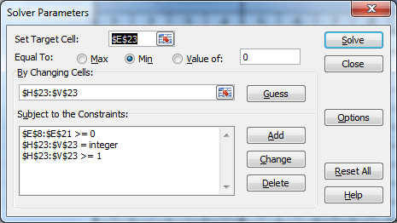
Fig 2.7.15: Solver parameters
The target cell is set as the sum of excess cells. The Equal to field is set as Min. The changing cells are set to the hired cells for each schedule. All the three constraints are added in the constraints field. Once you run the solver, you will find the optimum count required for hiring executives for each schedule.
- Example 4: A company selling products like mobiles, watches, shoes, household items need effective advertisements to reach different society of people and finally to their survival in market. Consider yourself as part of an advertising company to whom MAXIMUS mobile company has approached for the advertisement of their new touch pad phone. They have mentioned the category of people to which the product the product is designed. They have also given the total budget allocated for the advertising cost. Consider there are 10 magazines circulated in the market which has different exposure to different kind of people or reader group (A-H). Figure 2.7.16 shows the different magazines and the advertising cost for each of them. Figure 2.7.17 shows different magazines and its exposure of each reader group in thousands. According to the client (MAXIMUS mobiles), they require that there product reach to C, D, E, F reader groups. Your job is to maximize the exposure for these groups and also keeping in consideration the total budget allocated.
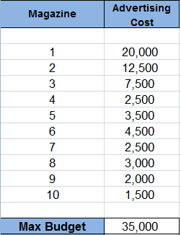
Fig 2.7.16: Different magazines and the advertising cost
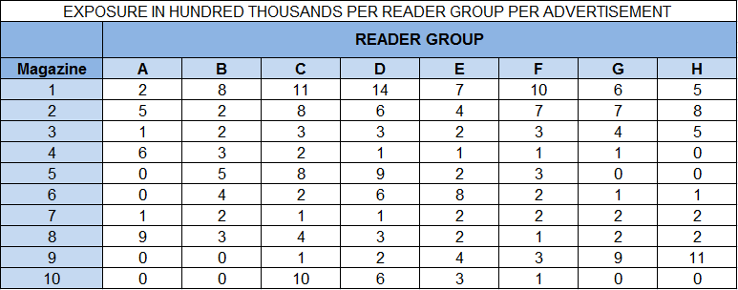
Fig 2.7.17: Exposure of each reader group in thousands for each magazine
Figure 2.7.18 shows the overall process done in excel. The maximum budget allocated is 35000 as shown in cell C19. Row F21:M21 should which all reader groups does the client wants. The magazine selector information is given is column B8:B17. It is a binary value which can be 1 or 0. This will be modified by the solver to get best combination. The exposure row F19:M19 shows the count obtained in each reader group with the help of current magazine selector information. It is given by formula =SUMPRODUCT($B8:$B17,F8:F17). Cell C20 shows the Total cost required with the current magazine selector combination. It is calculated by SUMPRODUCT function between the magazine selector and advertising cost columns. The total exposure for the reader groups as per the client requirements is calculated in cell C23 using the formula =SUMPRODUCT(F19:M19,F21:M21) between the exposure row (F19:M19) and reader requirement of the client (F21:M21). This is the objective function which you have to minimize along the constraints that total cost should not exceed the budget. Figure 2.7.19 shows the solver and the required parameters. Please note that we have added one more constraint that the magazine selector values should be binary.
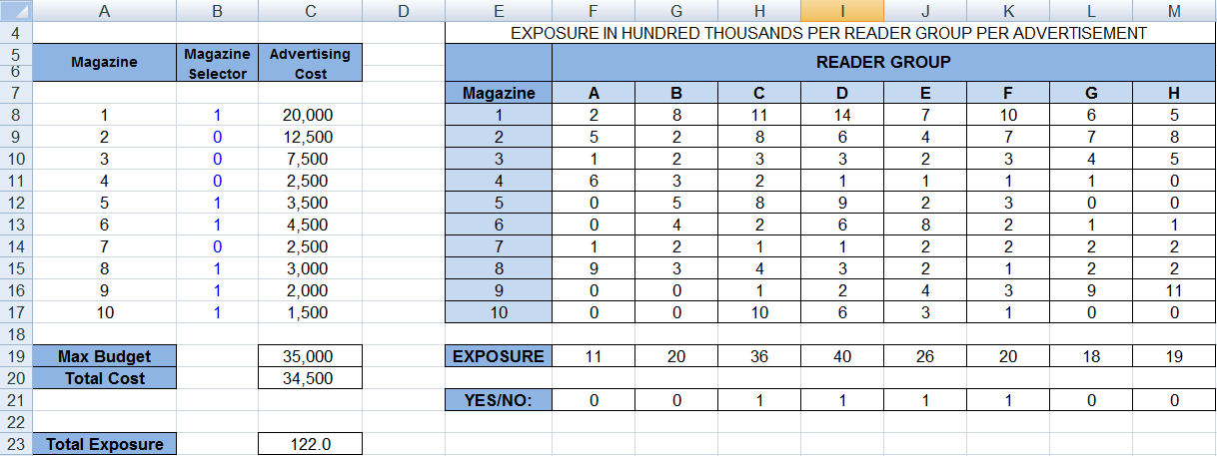
Fig 2.7.18: Overall process
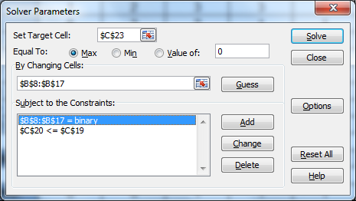
Fig 2.7.19: Solver parameters
Once you run the solver, you give get the optimum magazine selection information which gives the maximum exposure to the given reader groups and within the allocated budget.

2.8 VBA and Excel
With the help of VBA (Visual Basic for Applications), many mundane tasks can be made easier and interesting as well. VBA allows user to create good spreadsheet applications that would automate various work. One of the best tools available is the macro recorder, which records the user actions and the recorded actions can be rerun as many times as wanted. The macro recorder is an ideal tool for a novice and can learn VBA through that, by recording the actions and then looking at the code [10].
The usage of VBA depends on the understanding of the Object model of MS Excel. The user can program an application using the objects that the application exposes.
Excels Object model exposes several very powerful data analysis objects, such as worksheets, charts, pivot tables, scenarios, and numerous mathematical, financial, engineering, and general business functions. VBA allows the user to work with these objects and develop automated procedures. Note that XLM (macro language) is not compatible with Excel 97 version on.
The Excels object model can be thought of as hierarchy with the Application object at the top and it contains the other objects (47 objects, to be precise). This object hierarchy lends itself well to unleash the full power of Excel.
The actions to be performed are done by executing the VBA code, which appears inside the modules. The VBA modules can be viewed and edited using the Visual Basic Editor (VBE). The VBE is a separate application that works seamlessly with Excel and the Excel should be running to activate the editor. There can be Sub procedures, Function procedures, Property procedures and Declarations in a module.
Excel also provision for creating user forms, custom dialog boxes for the user built applications. The user forms give a greater control over custom dialog boxes.
2.9 Summary
Microsoft Excel is the most successful product of Microsoft excel. It enabled managers to effectively and easily analyze business data. Excel is power by its ability to represent data in row-column format. Add-in such as Solver, What-If Analysis (available with MS Excel 2007) adds to the potential; of MS-Excel. This chapter aims at showing the power of Microsoft Excel by solving simple optimization problems and management level problems. The chapter also mentions about commonly used MS-Excel function with examples. Apart from other aspect it also provides programming capabilities with the help of Macros (VBA programs).
Saying about excel, “To an extend MS-Excel is an intelligent tool, but it is only as intelligent as you”. It is up the user to effectively utilize its potential in problem solving.
Questions:
- Electronic communications manufacture portable radio systems that can be used for two-way communication. The company’s new product which has a range upto 25 miles is suitable for use in a variety of business and personal applications. The distribution channels for new radio are:
- Marine equipment distribution
- Business equipment distribution
- National chain of retail stores
- Direct mail
Because of differing distribution and promotion cost the profitability varies. In addition, the advertising cost and the personal sales effort required will vary with distribution channels. The table 1 summarizes the contribution of profit, advertising cost, and personal sales effort:
Distribution channel | Profit per unit sold ($) | Advertising cost  ($) | Personal sales effort (Hrs)
A | 90 | 10 | 2
B | 84 | 8 | 3
C | 70 | 9 | 3
D | 60 | 15 | -
Table 1: Distribution Channel Data
The firm has set a budget at $5000 and a maximum of 1800 hours of sales force time is available for allocation of the sales effort. The management also decides to produce the exactly 600 units for the current product variable. Finally, an ongoing contract with national chain of retail stores requires 150 units to be distributed through this distribution channel. Electronic communications is faced of problem determining number of units that should be produced for each channel in order to maximize total profits.? Help them in solving this problem?

- High Tech Industries imports electronic components that are used to assemble two different models of personal computers. One model is called the HT Deskpro Computer, and the other model is called the HT Portable Computer. High Tech’s management is currently interested in developing a weekly production schedule for both products.

The Deskpro generates a contribution of $50 per unit, and the Portable generates a profit contribution of $40 per unit. For next week’s production, a maximum of 150 hours of assembly time can be made available. Each unit of the Deskpro requires 3 hours of assembly time, and each unit of the Portable requires 5 hours of assembly time. In addition, High Tech currently has only 20 Portable display components in inventory; thus, no more than 20 units of the Portable could be assembled. Finally, only 300 square feet of the warehouse space can be made available for new production. Assembly of each Deskpro requires 8 square feet and each Portable requires 5 square feet of warehouse space. Suggest how many of each model should be produced.

Selecting Advertising Media
Suppose that you work for a company that advises clients on the selection of magazines in which to advertise their products. A market research firm supplies data on the nature of the readers of various magazines. The readership of these magazines is broken down into eight groups such as adolescents, retired, etcetera. An exposure is defined as the number of readers expected to view a full page advertisement of the magazine.
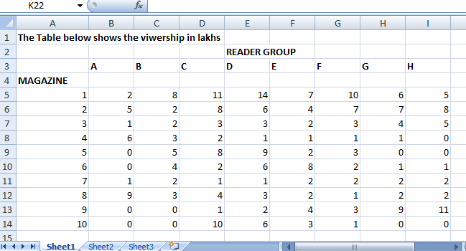
Fig 1: Magazine Data
The Fig 1 gives the information regarding the viewership of each reader group in the 10 magazines .For instance an advertisement placed in magazine 1 targeted for reader groups C and D would reach 1,100,000 readers in group C and 1,400,000 readers in group D for a total exposure of 2,500,000.
Assuming that the table of data is acceptable, and then the challenge facing a company is to reach the largest audience for a given advertising budget. The audience is those reader groups that buy the company's products.
The Fig 2 gives the advertising cost for the 10 magazines.
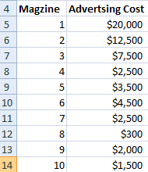
Fig 2: Advertising Costs for each Magazine Type
- How would you select the magazines so that you get maximum exposure for your company within the given advertising budget of $35000?

- What would you have to do to change the nature of the problem from maximizing exposures for a given budgetary limit to minimizing cost for a desired level of exposures?

- What would be the minimum amount of money necessary to have at least 150 exposures?
(HINT: Try to obtain a solution by using a "toggle switch" for identifying desired reader groups and the function SUMPRODUCT() ).
References
[1] David George, “The ABC of SEO”, Search engine optimization strategies
[2] John Walkenbach, “Excel 2007 Bible” ISBN:0470044039
[3] Nargundkar, Rajendra. “Marketing Research Text and Cases”.
[4] ”Optimization Techniques – Web chapter A”: http://www.cengage.com
[5] Roy L. Nersesian. “What’s Best Linear Programming”.
[6] Ragsdale, Cliff. “Spreadsheet Modeling and Decision Analysis” 3rd Edition p. no: 455.
[7] “Search Engine Optimization (SEO)”: http://www.innovativeoutsource.com/seo.html
[8] Solver samples: Program Files\Microsoft Office\Office12\SAMPLES
[9]” Solver Tutorial” : www.solver.com/tutorial.htm
[10] Walkenbach, John. “Excel 2000 Programming with VBA & Formulae”.

